Assuming the following fixed parameters,

Nbar = 1.0

Nstar = 0.1432394487827058

tau_eq = 1 microsecond

sigma0 = 0.2

when the “baseline” scenario is perturbed a little to the following:

L = 30 micrometer

D = 0.000365 micrometer ** 2 / microsecond

nu_kin = 105 micrometer / second

nu_kin_mlyperus = 0.26992287917737784 / microsecond

sigmaI_corner = 0.22 dimensionless

c_r_percent = 1.068 dimensionless

nx (crystal) = 2401

Spacing of points on the ice surface = 0.02499999999999858 micrometer

we get instability:

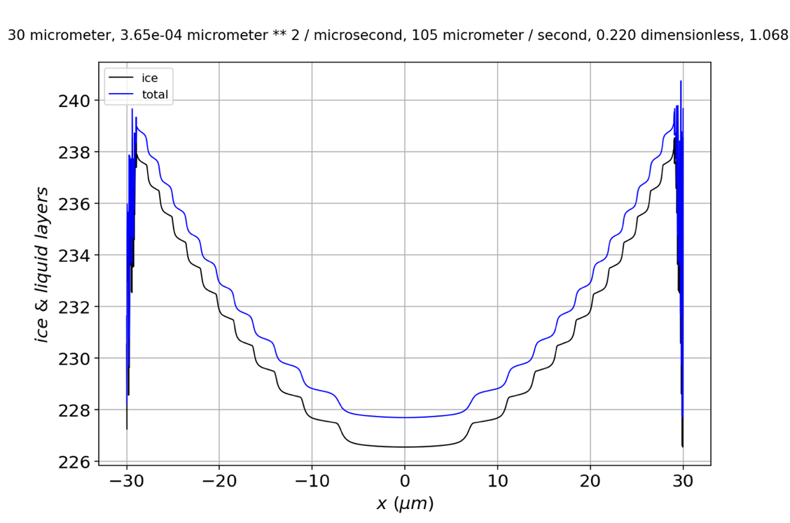

**Figure 1**. Profile showing unstable growth.

If we expand in the corner, it’s clear that instabilities have crept in, by this time, from the edge at $30 μm$ to $29 μm$.

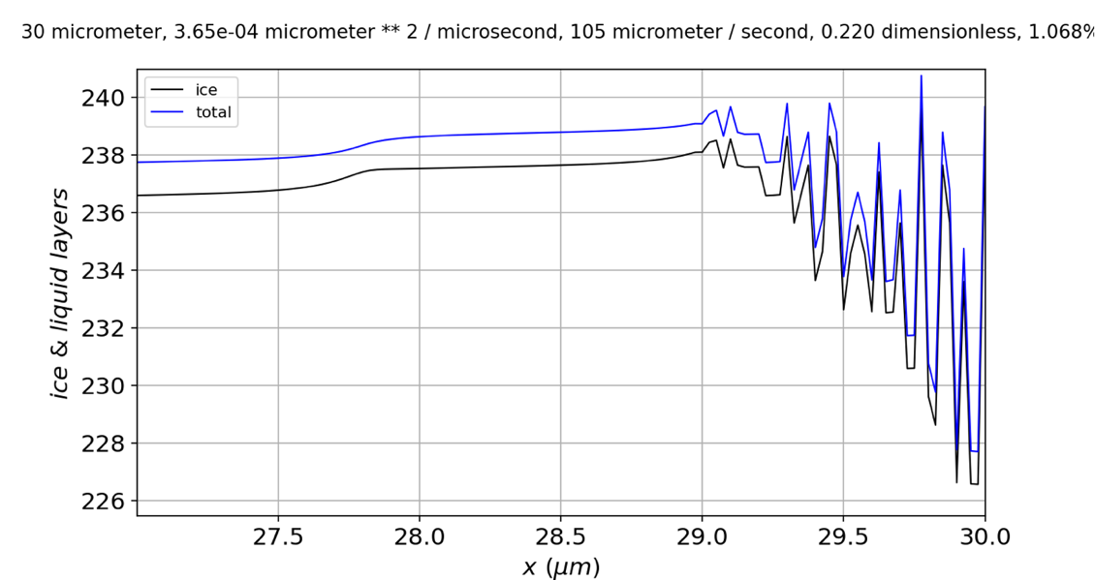

**Figure 2**. Expanded view of the profile in Fig. 1.

If we examine the $N_{QLL}$ alone,

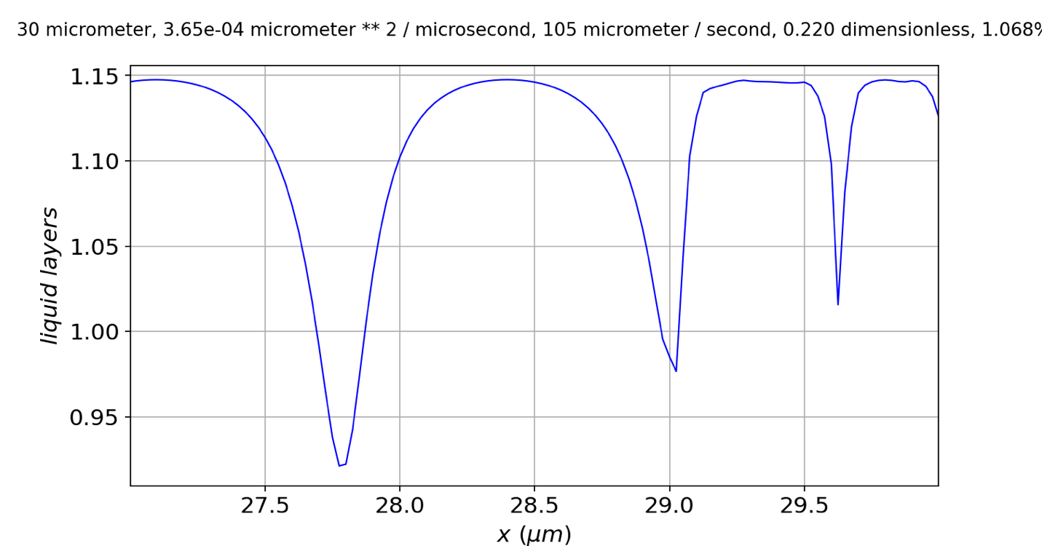

**Figure 2**. Quasiliquid thickness after onset of instability.

we see that the instability seems to originate on a *step*, rather than at a *riser* (solid arrow). The fact that $N_{QLL}$ tops out at risers generally (dashed arrows) with a value close to $1.148$ is significant, because the parameterization $N_{QLL}^{eq}(N_{tot})=\overline{N}-N^{*}sin⁡(2πN_{tot})$ means that when $sin⁡(2πN_{tot})$ is at its **maximum** value ($N_{tot}=\frac{3}{4}$), $N_{QLL}^{eq}\left(N_{tot}\right)=\overline{N}+N^{*}=1.143$. That means, at that time step, deposition from the vapor phase has slightly exceeded the ability of the quasiliquid to **freeze** or **diffuse away**. If this thinking is correct, then we can predict that stability can be favored by bigger $D_{QLL}$ (which is correct) and smaller $τ$ (which is incorrect).

OK, more data. **Stability is favored by**

* Smaller $D_{QLL}$ (from $0.000365$ to $0.0002\frac{μm^{2}}{μs}$)
* Bigger $τ$ (from $1$ to $1.1μs$)
* Bigger $ν_{kin}$ (from $105$ to $110\frac{μm}{s}$)
* Smaller $c_{r}$ (from $1.068\%$ to $1\%$)
* Bigger $dx$

At times 14.445 and 14.446, I get small jumps in $N_{tot}$:

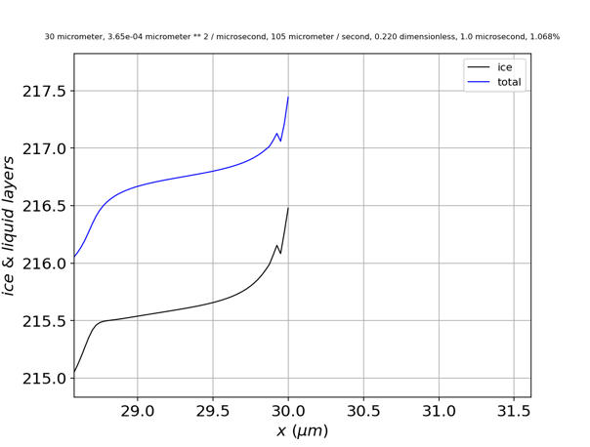 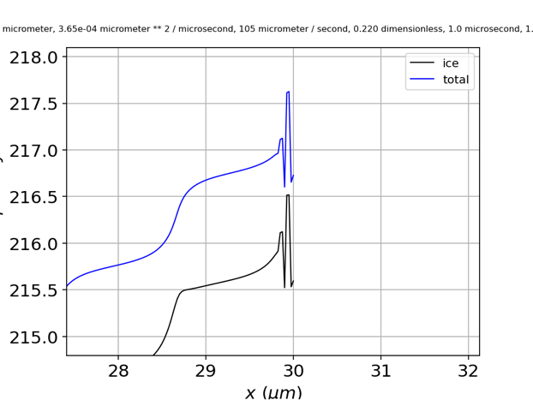

**Figure 3**. Evolution of a small-amplitude instability showing one glitch, then two.

Conclusions …

1. The glitches first appear close to **facet corners**. It’s still not clear whether this has something to do with the imposition of periodic boundary conditions at facet corners, or some other property, like lambda, which happens to be small at facet corners. I think I could explore this with **different supersaturation** profiles, or with **different boundary conditions** (see below).
2. The fact that glitches (when they first appear) are smaller in $N_{QLL}$ than in $N_{tot}$ suggests that they originate in **diffusion** or **deposition**, but **not freezing**. (See f1d_solve_ivp for a more detailed argument.)
3. In some cases, **glitches disappear in subsequent time steps**. An example is shown in Fig. 4: the glitch where the number of ice layers equals 210.5 (i.e., close to the riser at 30 micrometers) has disappeared at time step -14 (the riser now located closer to 29.4 micrometers).

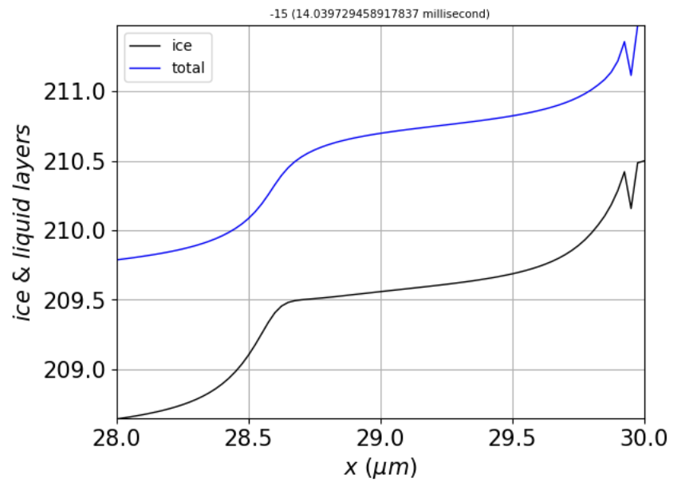 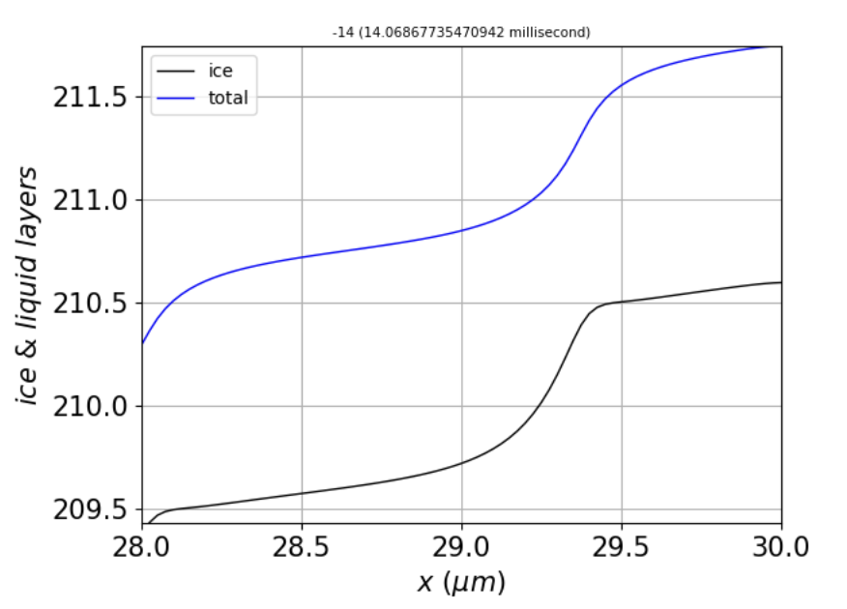

**Figure 4**. Left: Profile at time step -15. Right: Profile one time step later, showing removal of the glitch.

1. **When glitches persist** over time, however, they grow until they reach increments of $±1$ layer, then $±2$ layers, and so on. An example is shown in Fig. 5.

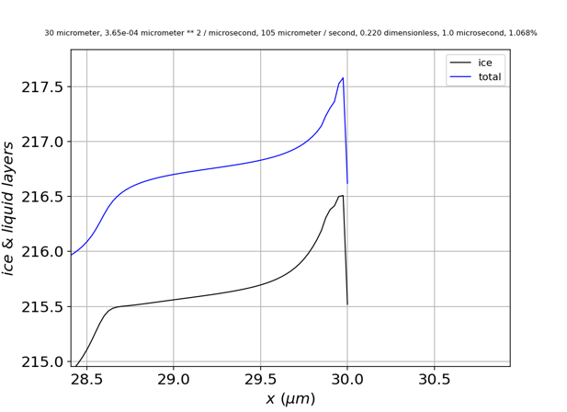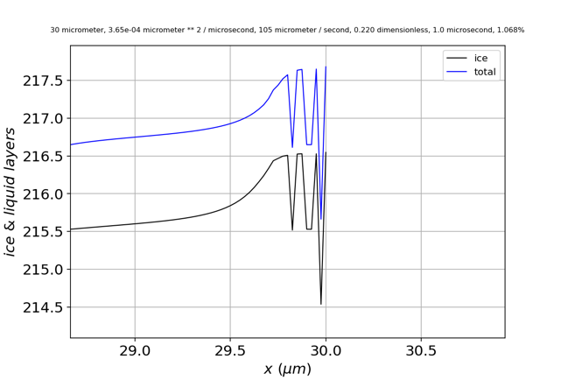

**Figure 5**. Evolution of the small-amplitude instability in Fig. 3 to full layer instability.

Examining **different boundary conditions**: If I replace **periodic boundary conditions** with **reflection** (no-flux) boundary conditions,

# Ntot diffusion

dy = np.empty(np.shape(NQLL0))

for i in range(1,len(NQLL0)-1):

dy[i] = DoverdeltaX2*(NQLL0[i-1]-2*NQLL0[i]+NQLL0[i+1])

# dy[0] = DoverdeltaX2*(NQLL0[-1] -2*NQLL0[0] +NQLL0[1]) # Periodic BC

# dy[-1] = DoverdeltaX2*(NQLL0[-2] -2*NQLL0[-1]+NQLL0[0])

dy[0] = DoverdeltaX2*(NQLL0[0] -2*NQLL0[0] +NQLL0[1]) # No-flux BC

dy[-1] = DoverdeltaX2*(NQLL0[-2] -2*NQLL0[-1]+NQLL0[-1])

the results are a little different, but the **glitches still occur**:

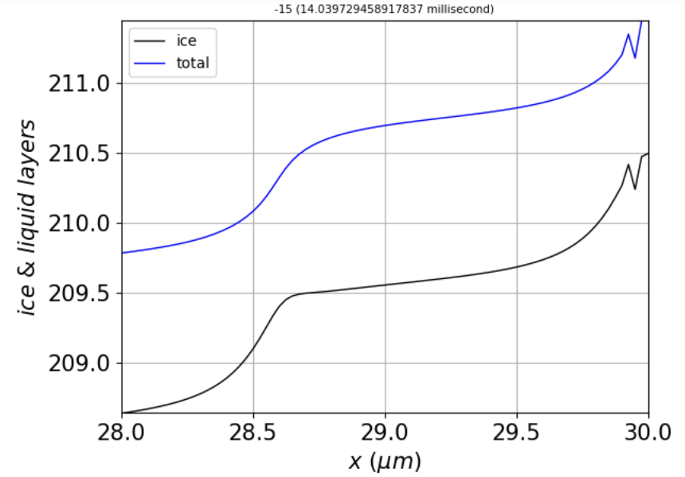

Left: **periodic** boundary conditions. Right: **reflection** (no-flux) boundary conditions.

The most this can mean, however, is that the imposition of periodic boundary conditions has been coded up correctly.

**Another thought**: what if we switch to an **implicit** integration method? They’re slower, so I had to back off on the spatial resolution (nx=801, instead of 2401 points).

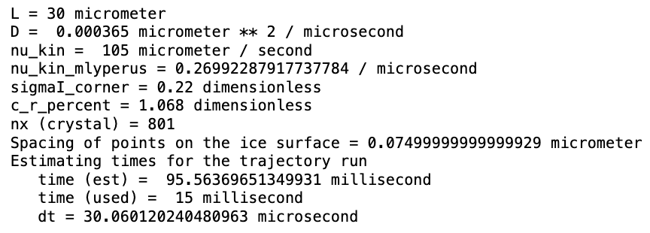

The results are encouraging, in that whereas all the explicit methods exhibited instability by 15 milliseconds, **BDF** remained stable:

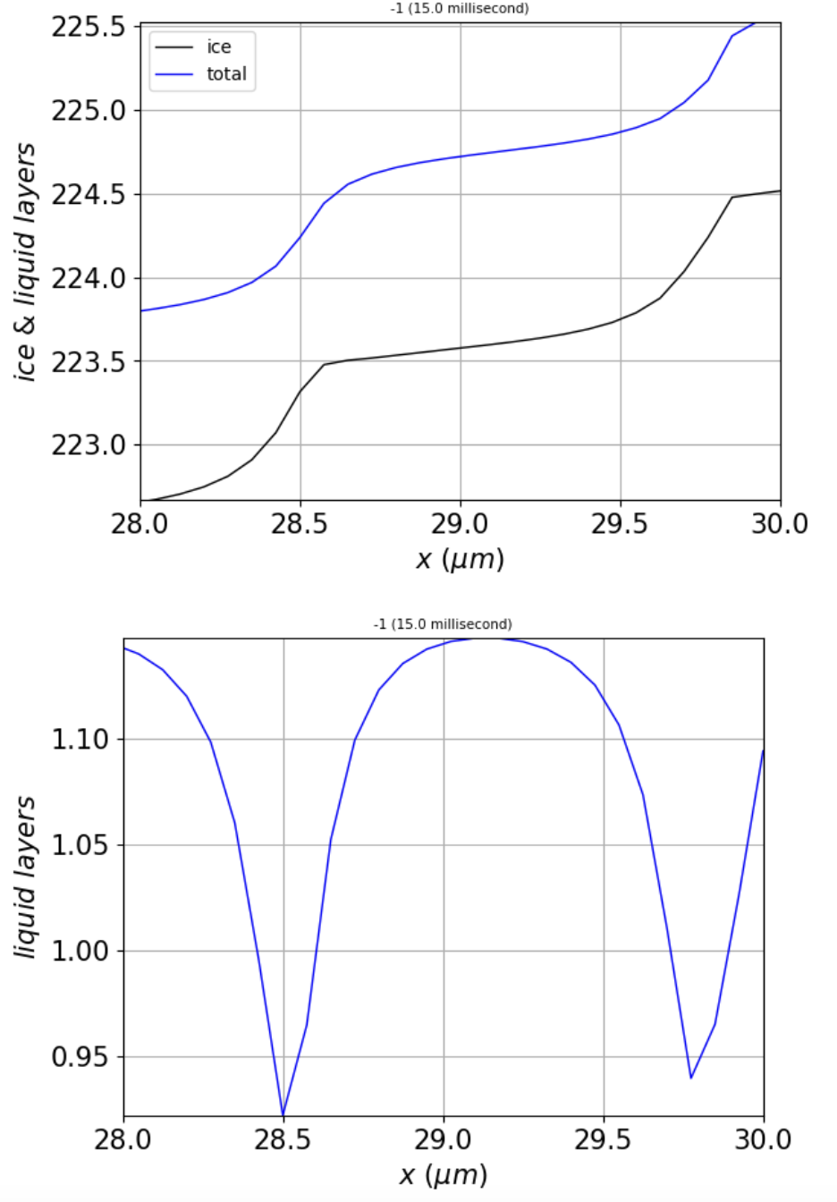

The step width is about $λ≈1.3 μm$ (at the corners).

This **BDF** run took about **10 minutes** on my laptop, which is on the order of 100x longer than the explicit methods I’ve tried (**RK23**, **RK35**, **LSODA**, or **DOP853**). **Radau** seems to be even slower, taking about 2x as long as **BDF**.

BDF doesn’t prevent instability altogether, however. When I reduce the corner supersaturation to **0.21** (from 0.22), for example, I get an onset of stability after 17 ms, which is when the number of steps reaches about 16, and the critical step width is $λ≈1 μm$ (at the corners).

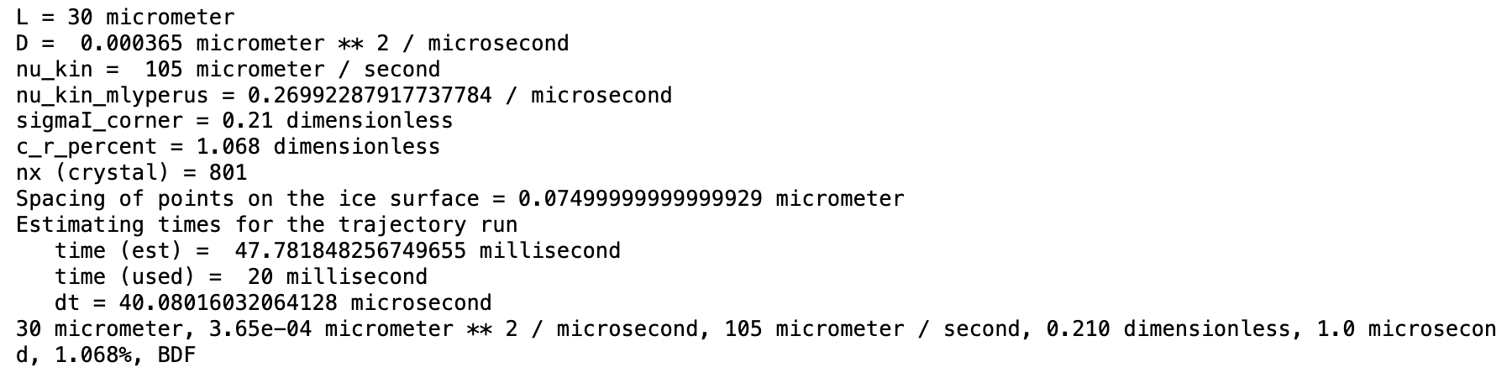

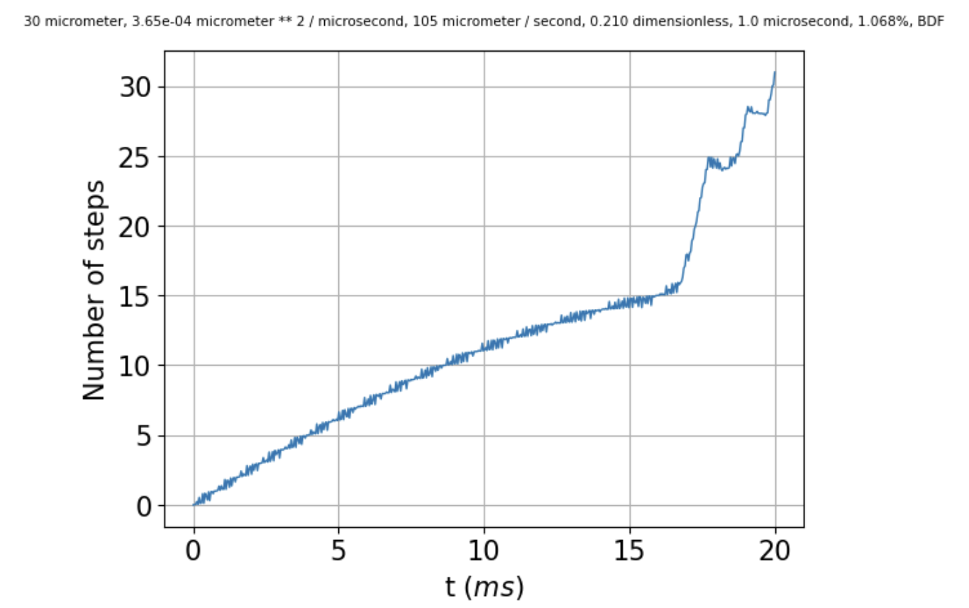 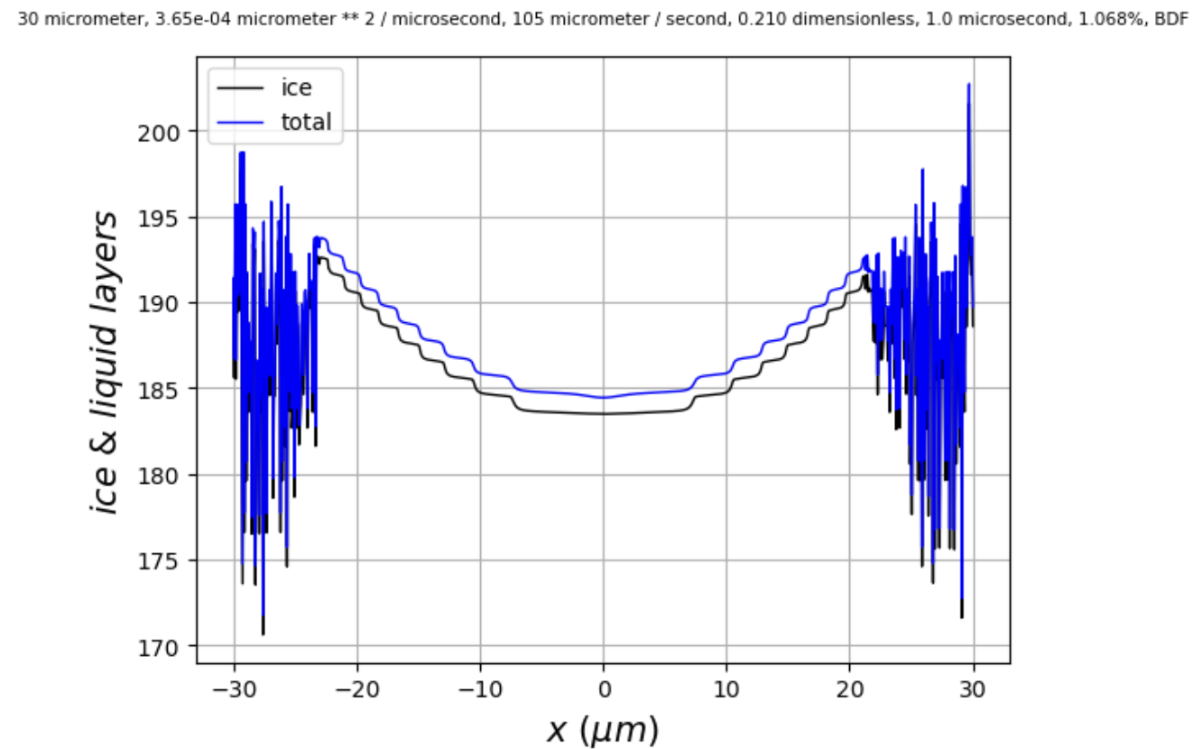

If we compare this to when the corner supersaturation is just a little bigger, at **0.215**,

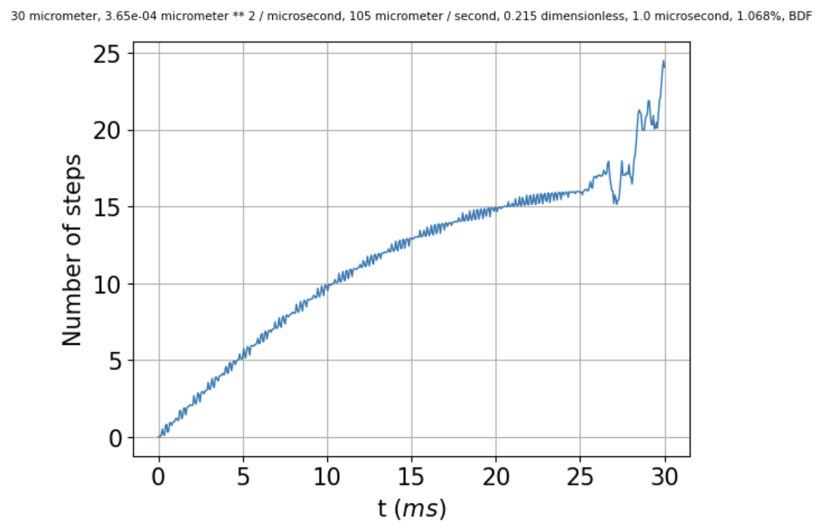 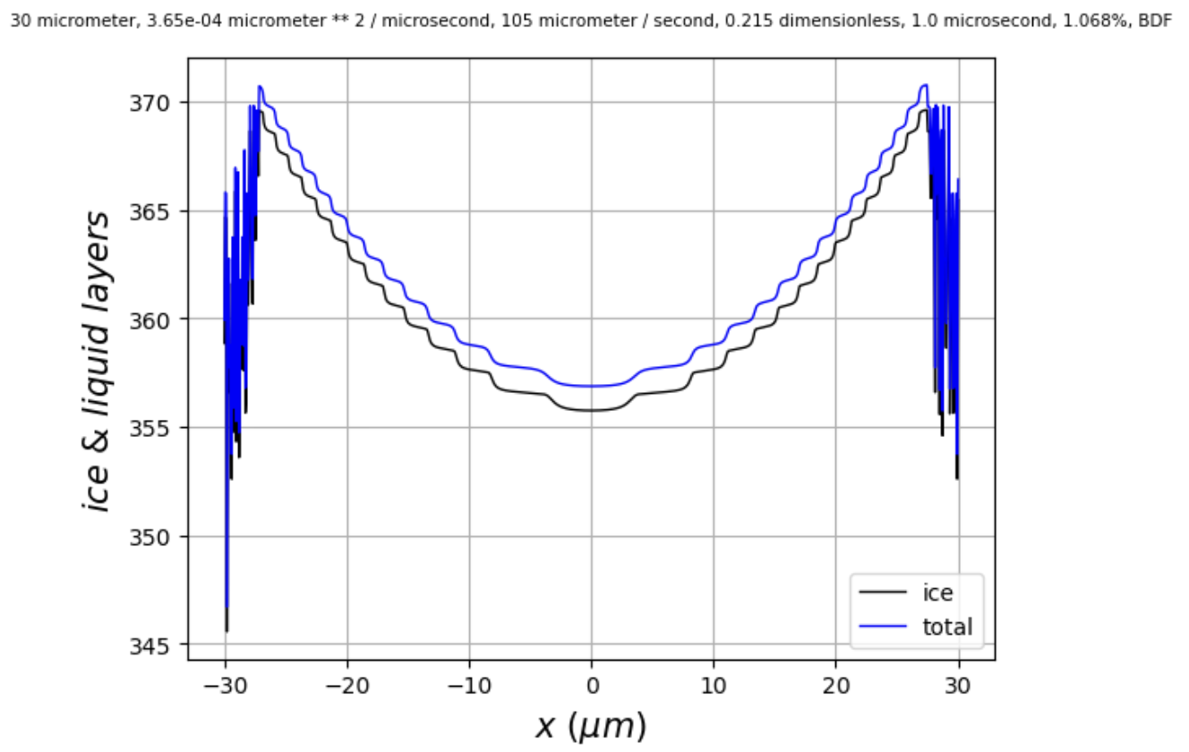

we see that instability sets in at a later **time** (25 ms), but at the **same number of steps** (16), which corresponds to a **critical** **step width** of $λ_{crit}≈1 μm$ (at the corners).

Below is a comparison of runs with $ν_{kin}=85$ vs $ν_{kin}=105$. Instability seems to set in at a smaller number of steps (closer to 14 steps, vs 16 steps in the run shown above). That means a **bigger critical step width**, $λ_{crit}≈1.1 μm$.

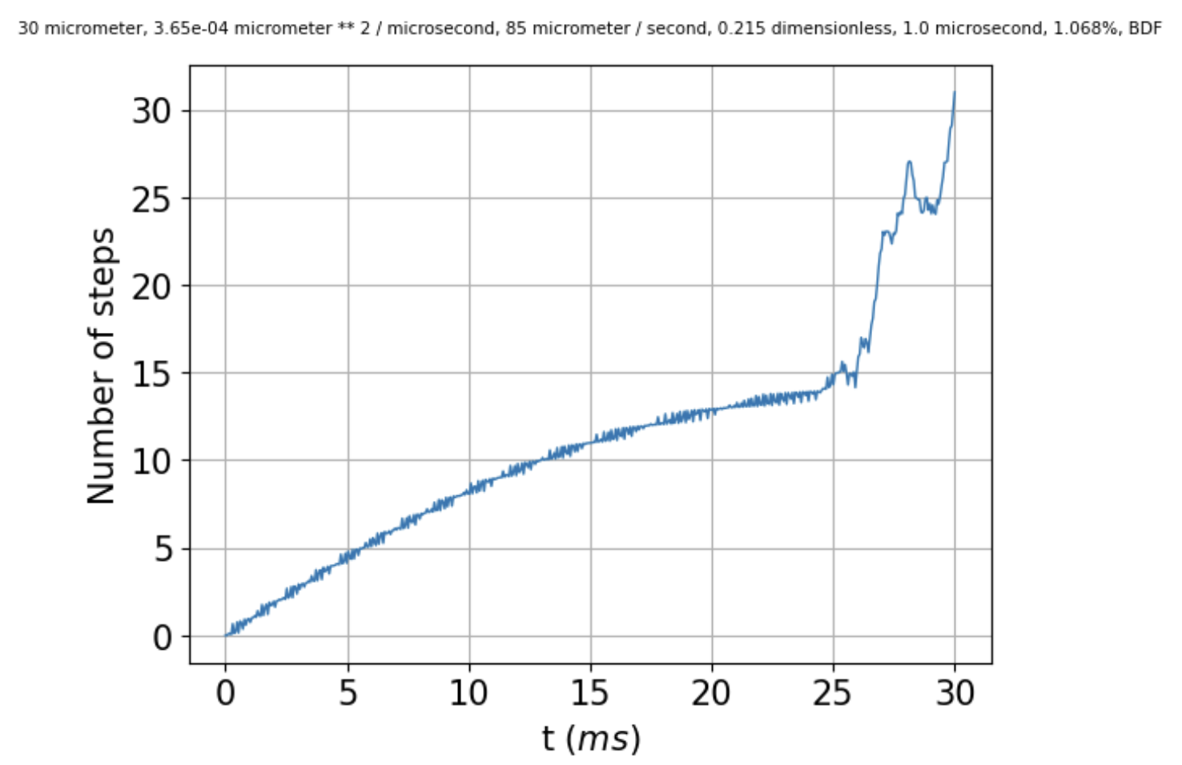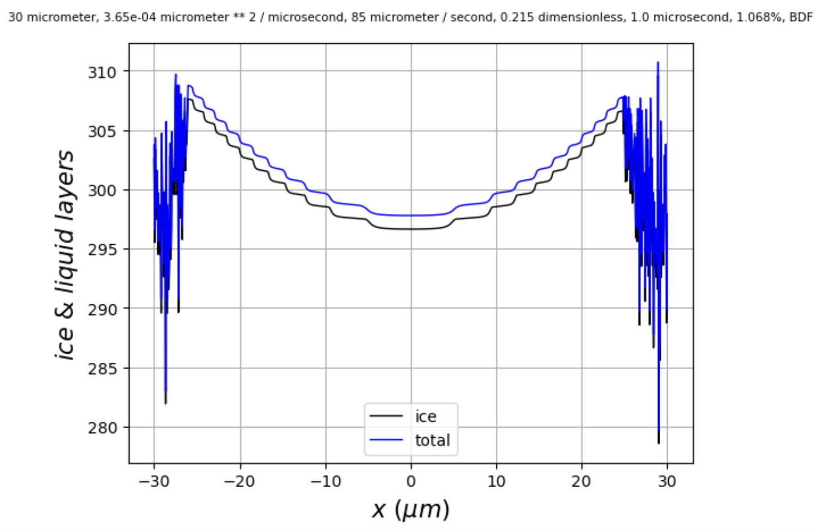

So from this, it would seem to be that the issue is **not** insufficient spatial resolution to capture the shape of the step.

According to the Princeton lecture notes in *cos323_f11_lecture19_pde2.pdf* (found [here](https://www.cs.princeton.edu/courses/archive/fall11/cos323/notes/cos323_f11_lecture19_pde2.pdf)) for the heat equation, stability requires that $Δt ≤ \frac{{\left(Δx\right)}^{2}}{2D}$. This would mean that the integrator must make $Δt$ smaller than a certain value. If the integrator has some minimum value of $Δt$, then there would be some minimum spatial resolution.

I think I’ve seen this while using RK45. The run on the left below has $Δx=0.150 μm$, while the run on the right has a higher resolution, $Δx=0.075$. That means the critical $Δx$ is $≈0.100 μm$, which in turn means (using $Δt ≤ \frac{{\left(Δx\right)}^{2}}{2D}$) that $Δt$ has to be smaller than $14 μs$.

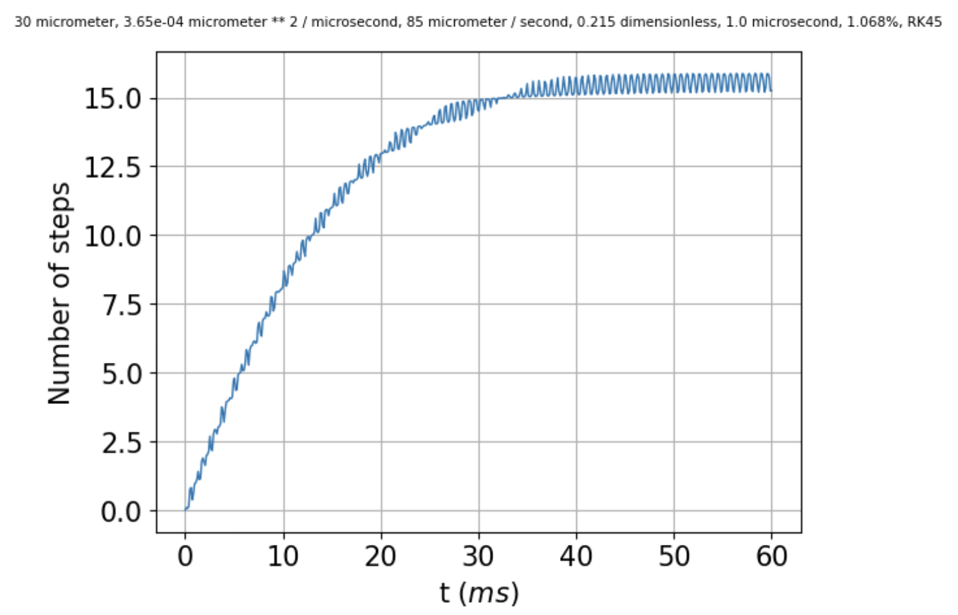 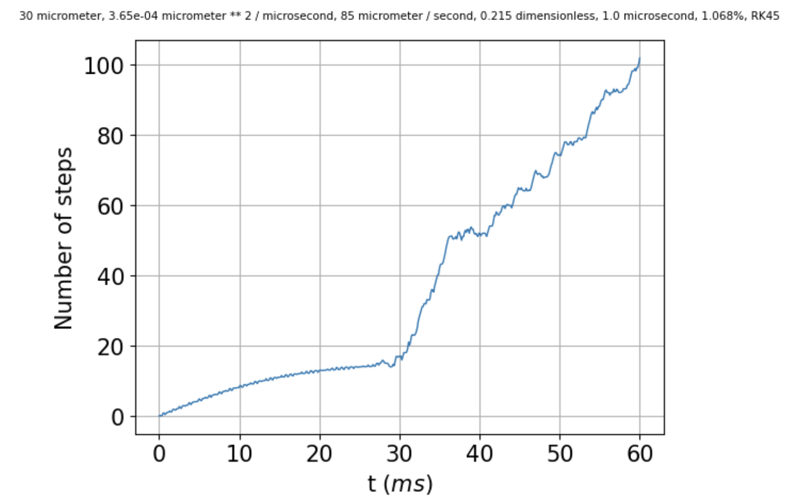

I don’t know how to query RK45 directly as to the time step it uses, but we can specify max_step in the call to scipy.integrate.solve_ivp. When that’s set to 1, there’s hardly any difference in run time. When it’s set to 0.1 (middle image below), the run time is noticeably longer, which tells me that RK45 is choosing a time step somewhere between 1 and 0.1 microseconds. The results are a little better at 0.1 microseconds, in the sense that the solution remains stable for a few more milliseconds (from 25 to about 28 ms). The kernel died when I tried max_step = 0.01, but when I set it to 0.02, the solution remained stable even a little longer (to about 29 ms).

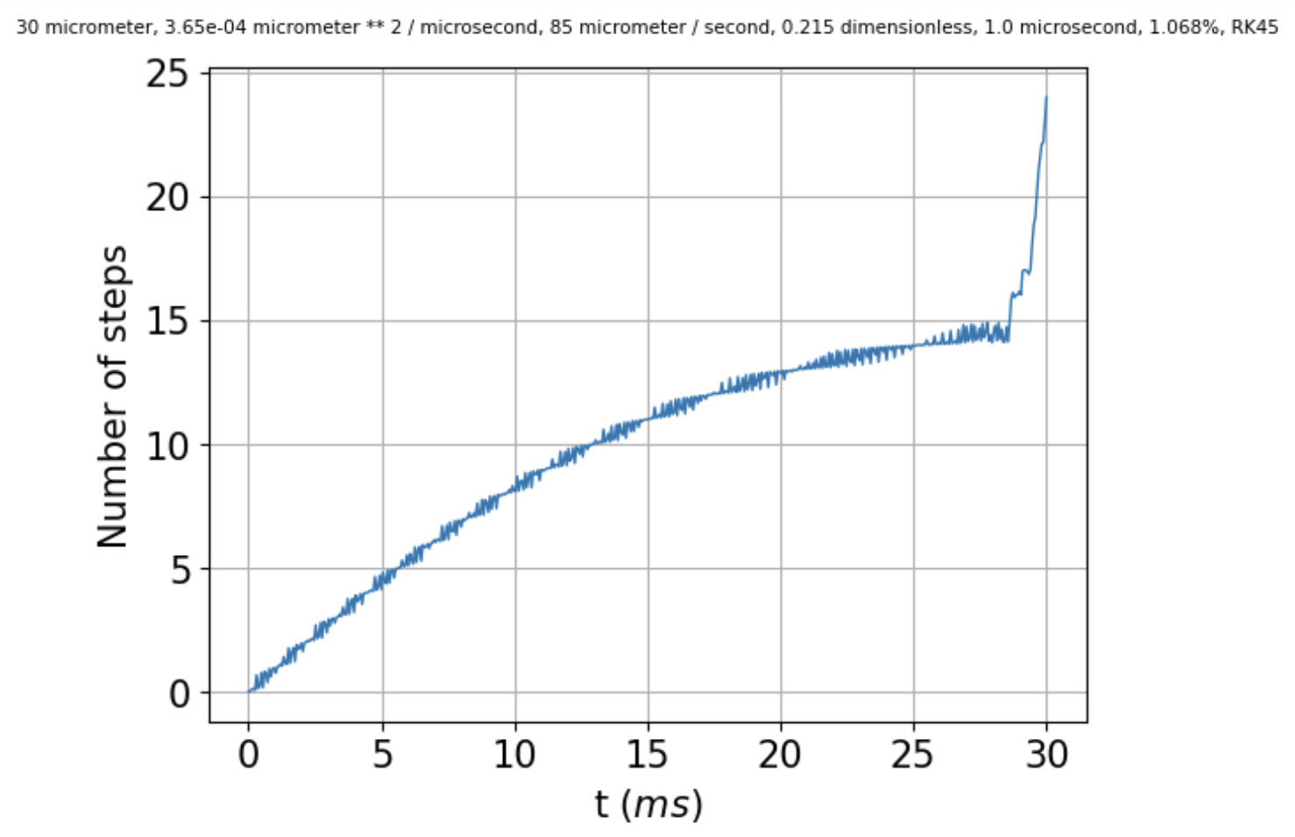 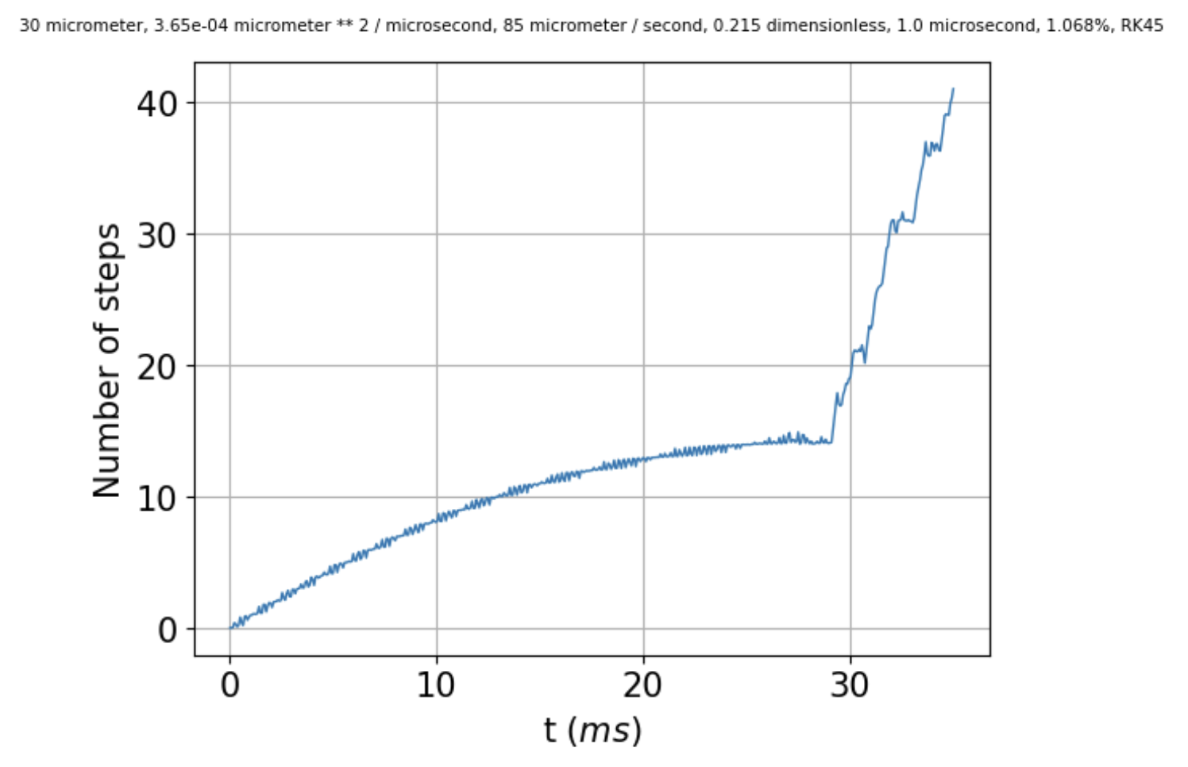

For comparison, [Chloe0x0x](https://github.com/chloe0x0/RK45/blob/main/src/rk45.py) uses a fixed time step of 0.01, which easily satisfies $Δt ≤ \frac{{\left(Δx\right)}^{2}}{2D}$.

*If we increase rtol, starting from ${10}^{-12}$, to ${1×10}^{-3}$, to ${2×10}^{-3}$ there’s hardly any difference until we get to the last one. Similar with atol, actually. So no help there.*

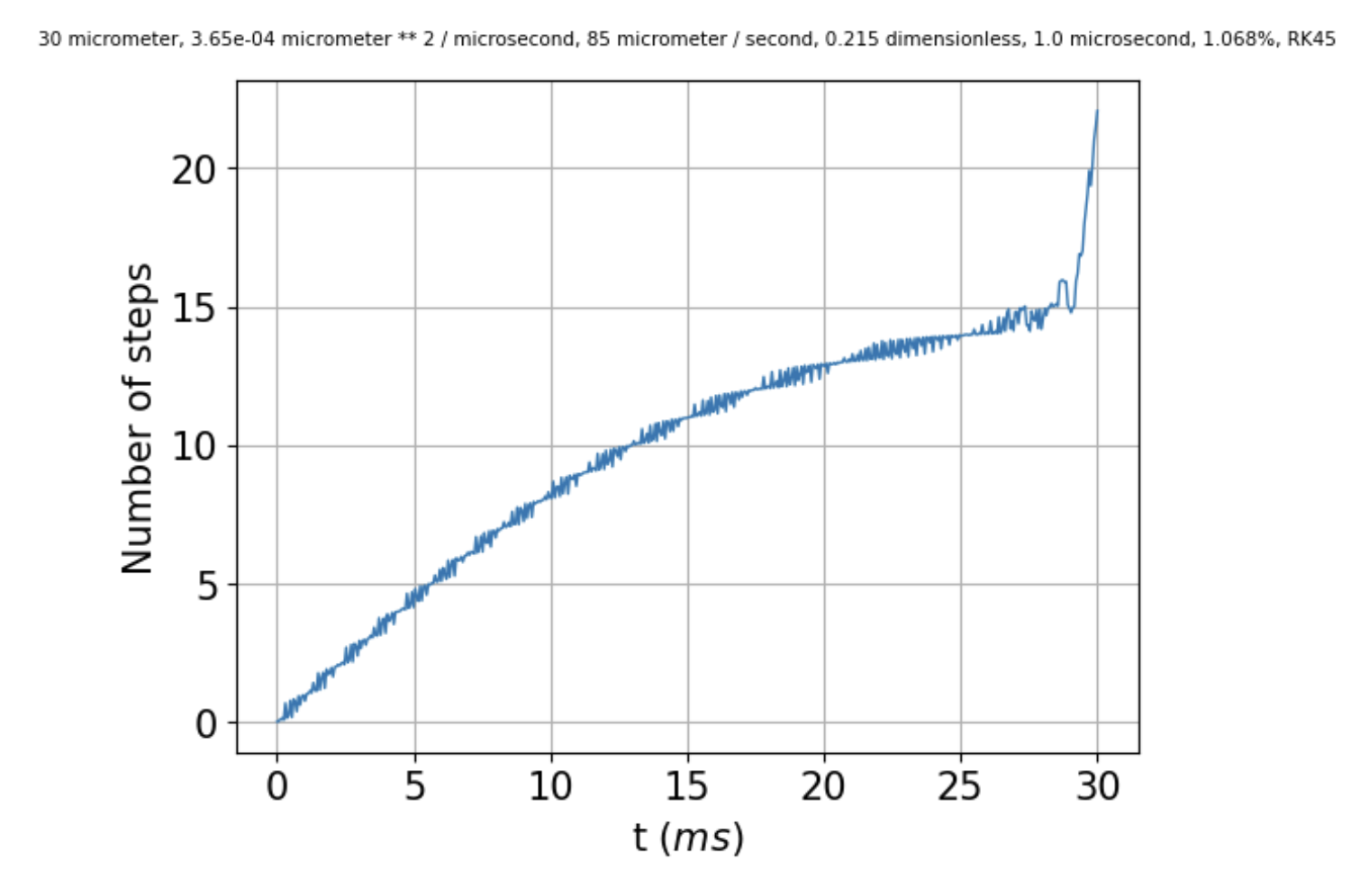 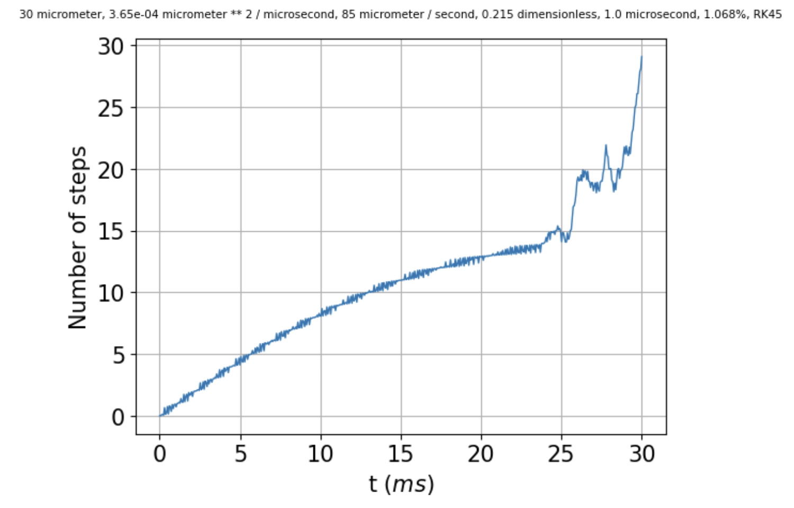 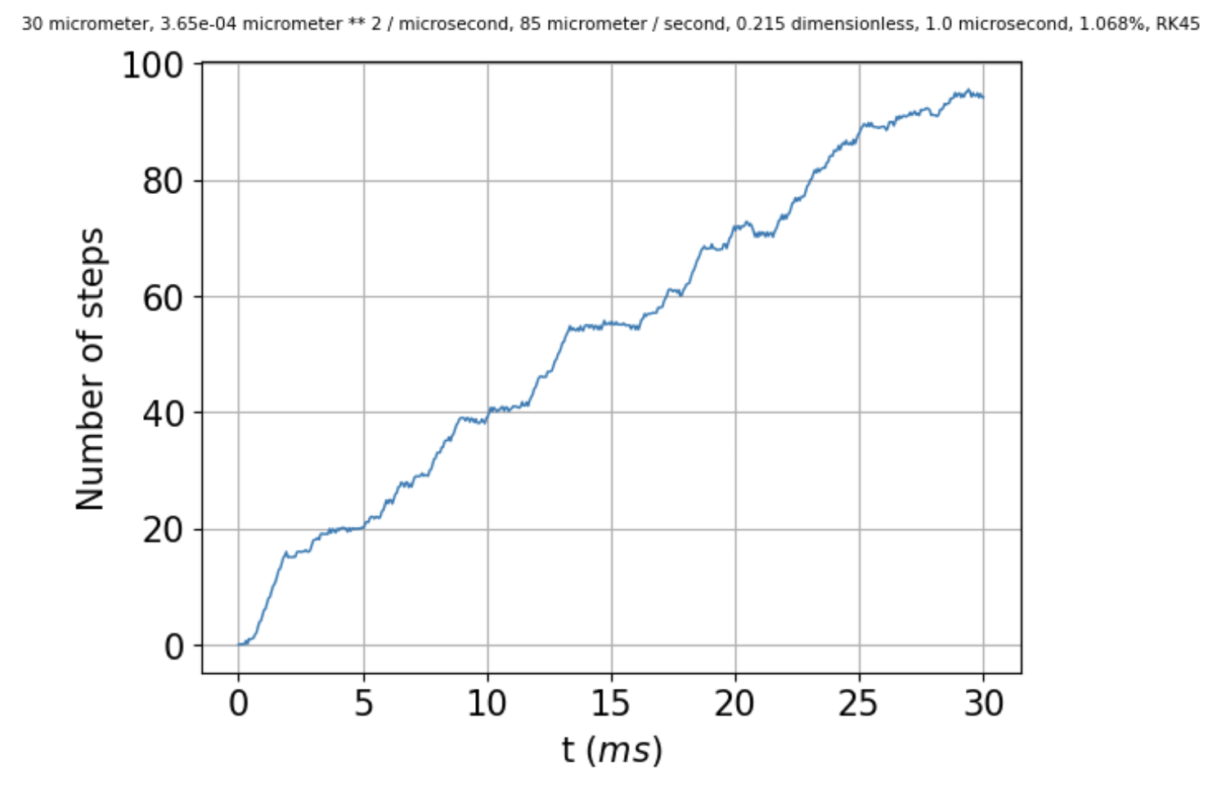

So, if specifying max_step improves matters (at least a little) for explicit methods, might it help for implicit methods? Duplicating



I get the following: no max_step specified on the left, max_step=1 microsecond in the middle (no help), and max_step=0.1 microsecond on the right.

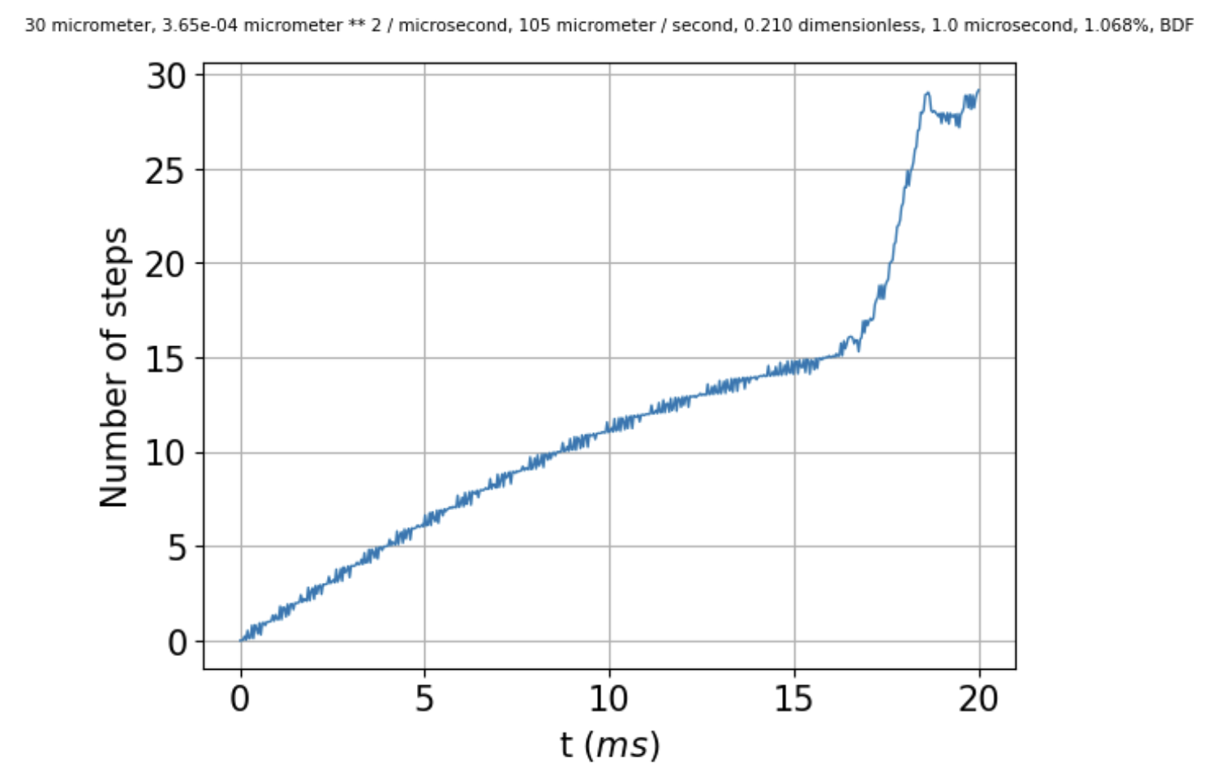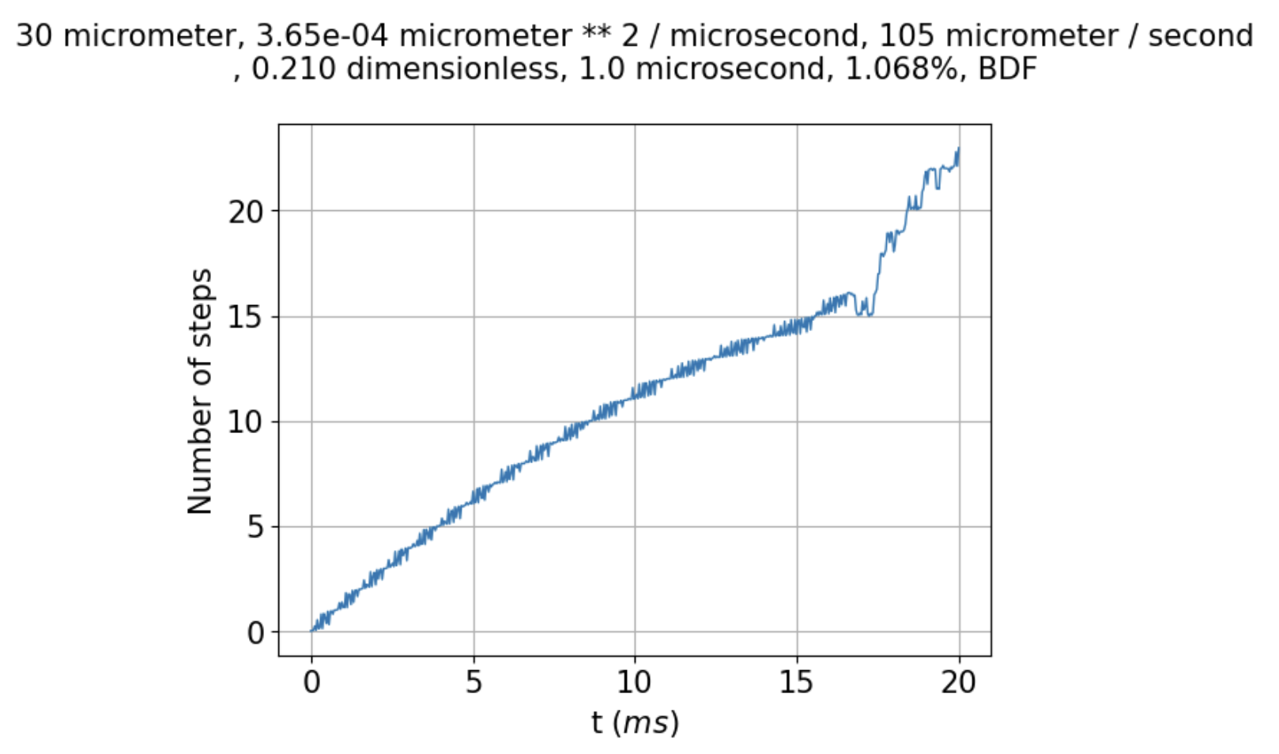

But there seems to be a difference now, in that the number of steps spanned when max_step=0.1 is a little tamer, going up to less than 25 by the end of the run.

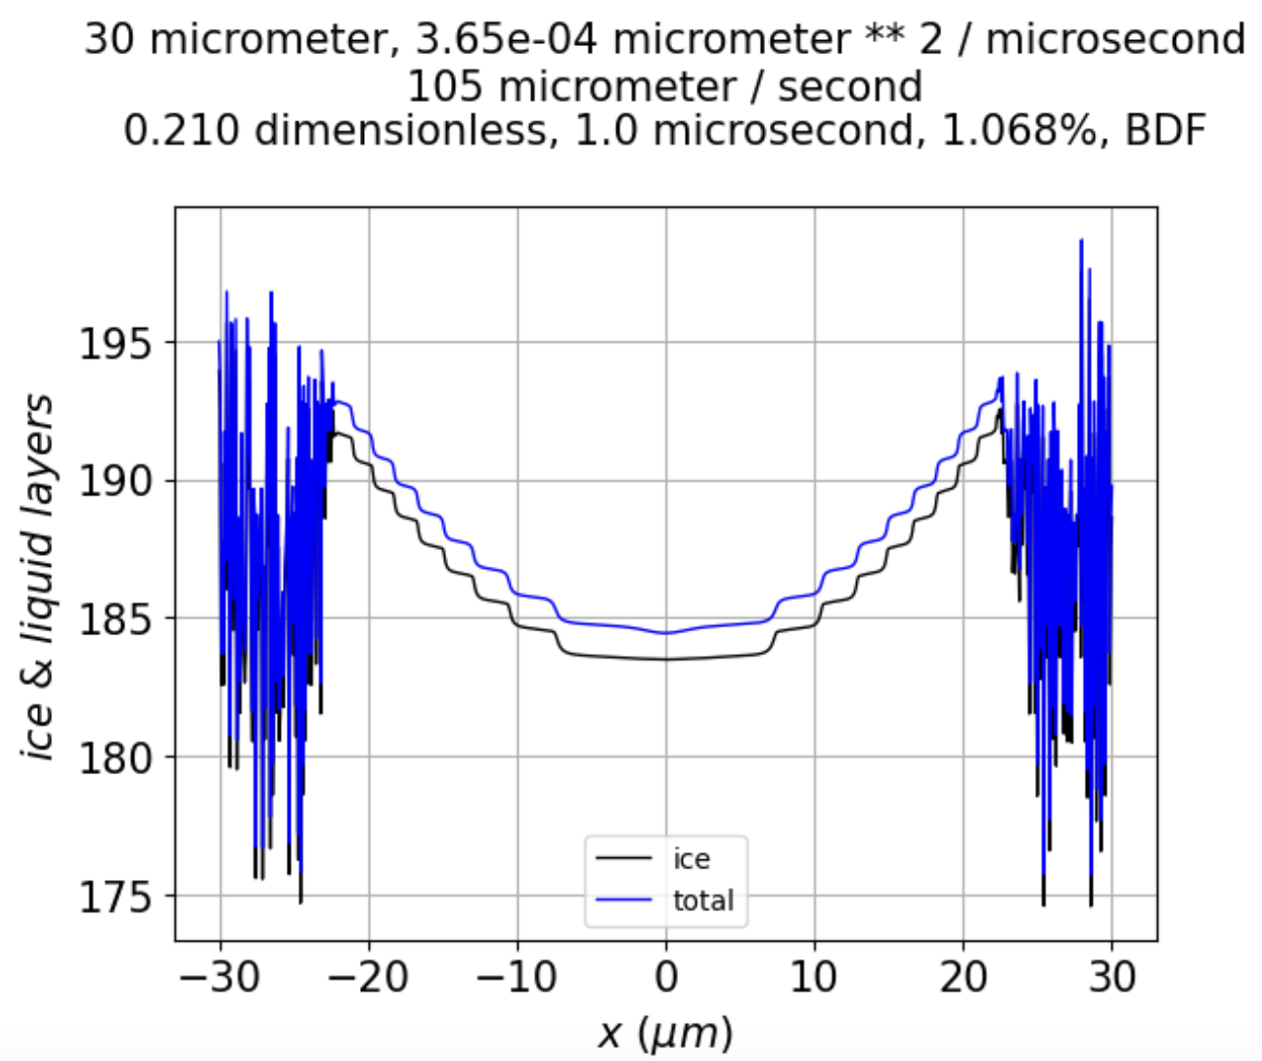

Instability at **risers** seems to persist longer, although they can still disappear over time, as shown by the red arrow below.

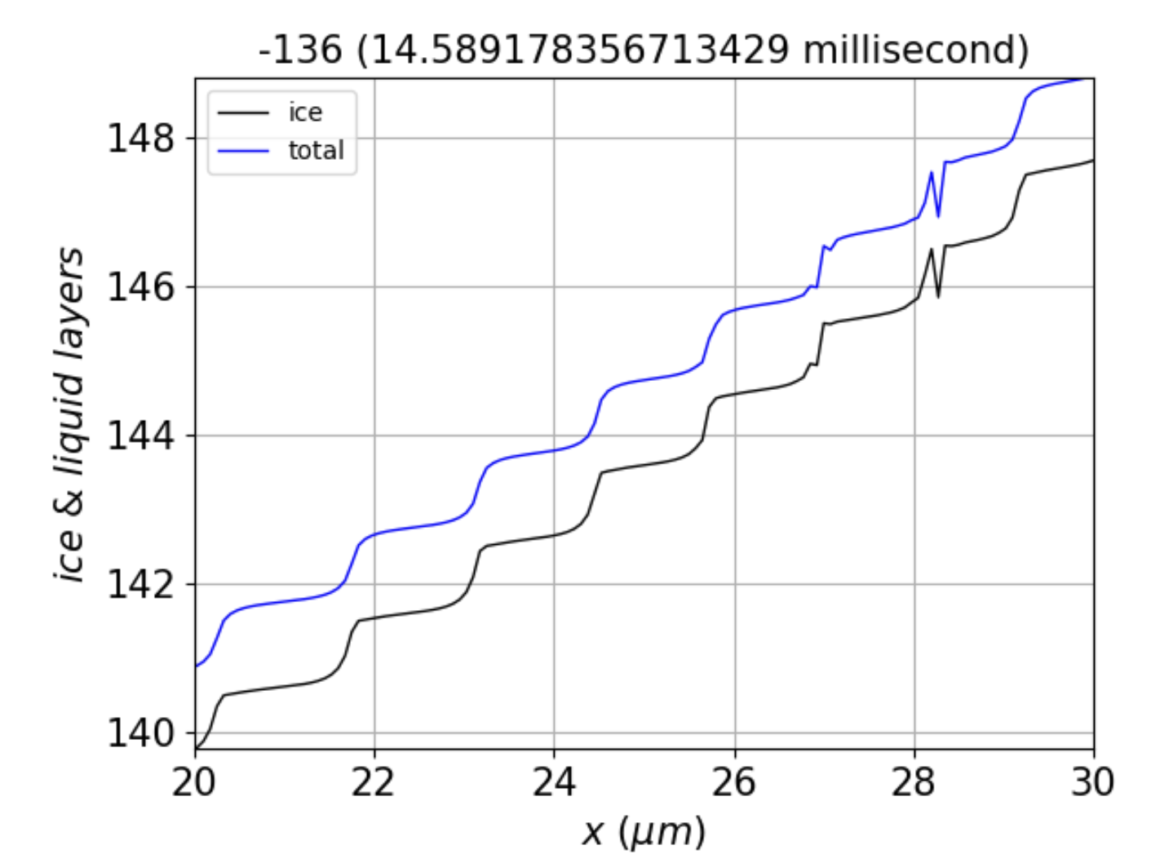 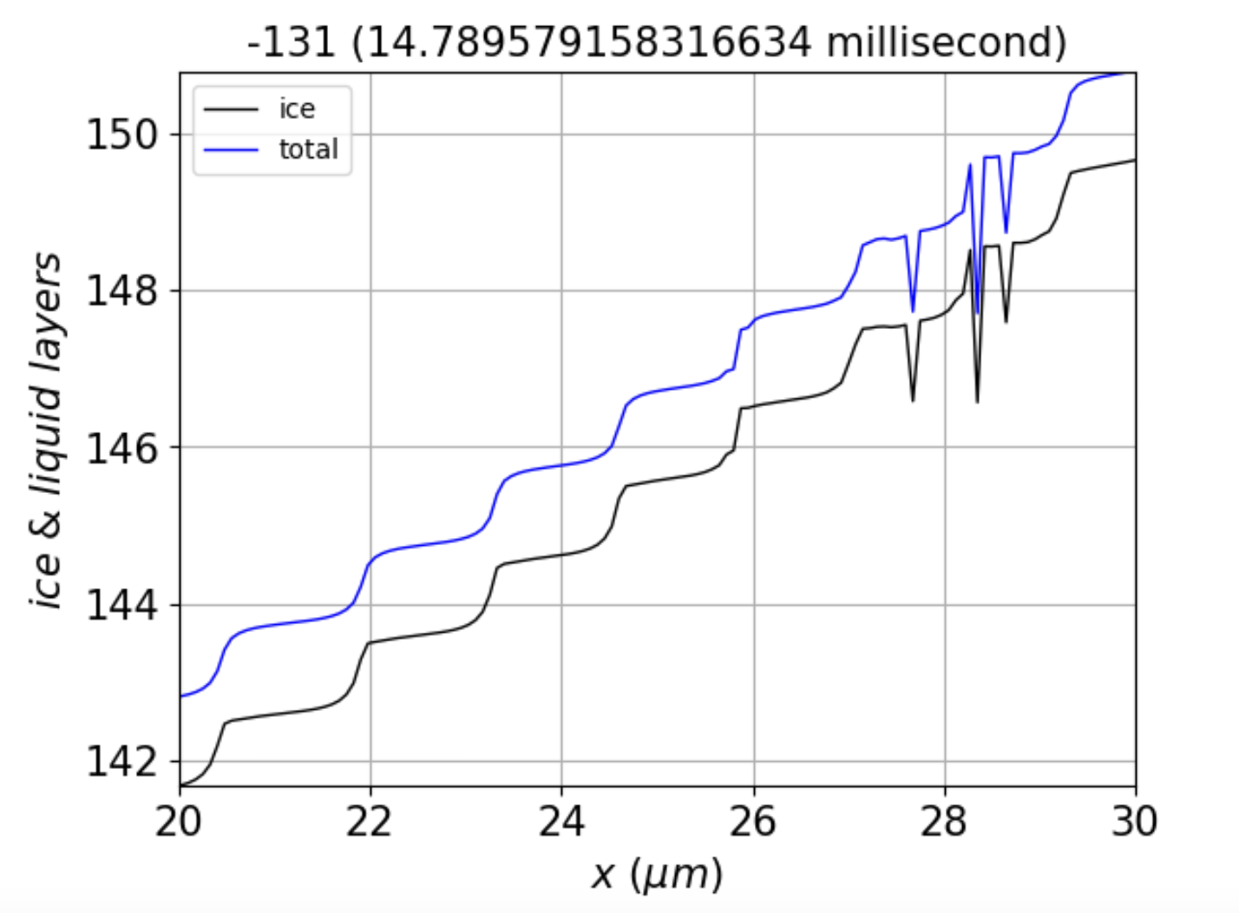

The fact that instabilities persist at risers, separated by $λ$, seems to point to roughness at a length scale related to $λ$ (although not necessarily equal to it).

So, what’s the answer? If we take seriously the Princeton formula, $Δt ≤ \frac{{\left(Δx\right)}^{2}}{2D}$, then it would seem that the much smaller value of $Δt$ required would have to be due to **some factor other than diffusion**. According to what I said at the beginning of this document, that would leave **deposition** as the likely culprit. But how does that help?

What I really want is a way to tell whether solutions to the PDE are unstable because:

1. The numerical algorithm is not up to the task, or
2. The instability is intrinsic to the PDE (under certain conditions).

**Thinking about a Fourier option.**

**“Scheme A”**

Say we express the total ice thickness as

$N_{tot}(x)=\sum_{j=0}^{j_{max}}{a_{j}cos\left(\frac{jπx}{L}\right)}$ (1)

and the QLL as

$N_{QLL}(x)=\sum_{j=0}^{j_{max}}{b_{j}}cos\left(\frac{jπx}{L}\right)$ (2)

Then if you put those expressions into $\frac{{∂N}_{tot}}{∂t}=D_{QLL}∇^{2}N_{QLL}+ν_{kin}σ_{m}$, multiply by $cos\left(\frac{jπx}{L}\right)/L,$ and integrate over $x$, it’s possible to derive expressions like

$\frac{{da}_{j}}{dt}=M_{j}b_{j}+B_{j}$ (3)

where (for $j=0$)

$M_{0}=-\frac{ν_{kin}σ_{0}}{2N^{*}}$ (4)

$B_{0}=ν_{kin}\left(σ_{0}×\left(\frac{\overline{N}}{N^{*}}-1\right)/2+σ_{I,corner}×\left(1-\frac{2}{3}c_{r}\right)\right)$ (5)

while (for $j>0$)

$M_{j}=-\frac{ν_{kin}σ_{0}}{2N^{*}}-\frac{j^{2}π^{2}D_{QLL}}{L^{2}}$ (6)

$B_{j}=-ν_{kin}\frac{4c_{r}σ_{I,corner}}{j^{2}π^{2}}$ (7)

(see the Python code *k-space solution.ipynb*).

For b-coefficient derivatives, we start with $\frac{{∂N}_{QLL}}{∂t}=\frac{{∂N}_{tot}}{∂t}-\left(N_{QLL}-N_{QLL}^{eq}(N_{tot})\right)/τ_{eq}$, and again multiply by $cos\left(\frac{jπx}{L}\right)/L$ and integrate over $x$, giving

$\frac{{db}_{j}}{dt}=\frac{{da}_{j}}{dt}+\frac{1}{{Lτ}_{eq}}\int_{-L}^{L}{\left(N_{QLL}-N_{QLL}^{eq}(N_{tot})\right)×cos\left(\frac{jπx}{L}\right)dx }$ (8a)

$\frac{{db}_{j}}{dt}=M_{j}b_{j}+B_{j}+\frac{1}{τ_{eq}}\left(b_{j}-\frac{1}{L}\int_{-L}^{L}{N_{QLL}^{eq}(N_{tot}(x))×cos\left(\frac{jπx}{L}\right)dx }\right)$ (8b)

$\frac{{db}_{j}}{dt}=M_{j}b_{j}+B_{j}+\frac{1}{τ_{eq}}\left(b_{j}-{\tilde{N}}_{QLL,j}^{eq}(\vec{a}) \right)$ (8c)

with

${\tilde{N}}_{QLL,j}^{eq}(\vec{a}) ≡\frac{1}{L}\int_{-L}^{L}{N_{QLL}^{eq}(N_{tot}(x))×cos\left(\frac{jπx}{L}\right)dx }$ (9a)

${\tilde{N}}_{QLL,j}^{eq}(\vec{a}) ≡\frac{1}{L}\int_{-L}^{L}{N_{QLL}^{eq}\left(\sum_{j^{'}=0}^{j_{max}}{a_{j^{'}}cos\left(\frac{j^{'}πx}{L}\right)}\right)×cos\left(\frac{jπx}{L}\right)dx}$ (9b)

So basically, **Scheme A** runs the simulation in $a, b$ space (the Fourier space), except that to describe freezing and melting, we **inverse FT** the $a$ values to get $N_{tot}(x)$, use that to compute $N_{QLL}^{eq}(x)$, then **FT** the result to get back to $\frac{{db}_{j}}{dt}$.

Suppose we take an Euler’s approach to solving Eq. 3. Then

$a_{j}^{n+1}=a_{j}^{n}+{(M}_{j}b_{j}^{n}+B_{j})∆t$ (10)

$b_{j}^{n+1}=b_{j}^{n}+\left\{M_{j}b_{j}^{n}+B_{j}+\frac{1}{τ_{eq}}\left(b_{j}^{n}-{\tilde{N}}_{QLL,j}^{eq}({\vec{a}}^{n})\right)\right\}∆t$ (11)

A notational shift … replace $a_{j}$ with ${\tilde{N}}_{tot,j}$ and $b_{j}$ with ${\tilde{N}}_{QLL,j}$, then the above is written

${\tilde{N}}_{tot,j}^{n+1}={\tilde{N}}_{tot,j}^{n}+{(M}_{j}{\tilde{N}}_{QLL,j}^{n}+B_{j})∆t$ (12’)

${\tilde{N}}_{QLL,j}^{n+1}={\tilde{N}}_{QLL,j}^{n}+\left\{M_{j}{\tilde{N}}_{QLL,j}^{n}+B_{j}+\frac{1}{τ_{eq}}\left({\tilde{N}}_{QLL,j}^{n}-{\tilde{N}}_{QLL,j}^{eq}({\tilde{N}}_{tot}^{n})\right)\right\}∆t$ (12’)

**How many $j$-values do we need?** To get a sense of that, we can take cosine transforms of $N_{QLL}(x)$ and $N_{tot}(x)$ obtained from the x-space simulations. Here’s the result for $N_{tot}(x)$, truncated to have $j_{max}≈150$ (rather than $≈200$) in the expansion.

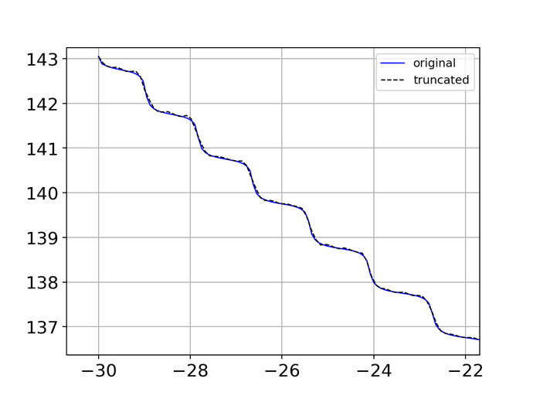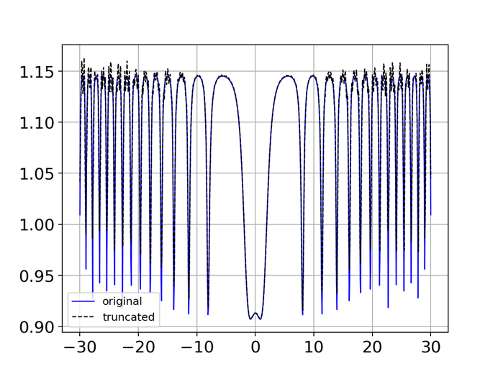

**Scheme “B”**

An alternative to the foregoing is to get $D_{QLL}∇^{2}N_{QLL}≡D$ in Fourier space. How?

1. Transform $N_{QLL}(x)=\sum_{j=0}^{j_{max}}{b_{j}cos\left(\frac{jπx}{L}\right)}$ to its Fourier space. Optionally, we can get rid of the high-frequency elements of $b_{j}$ (by *shortening* or *zeroing*) and create a truncated list (bj_list_tr).
2. Since $D=-\frac{π^{2}D_{QLL}}{L^{2}}\sum_{j=0}^{j_{max}^{'}}{j^{2}b_{j}}=-\frac{π^{2}D_{QLL}}{L^{2}}\sum_{j=0}^{j_{max}^{'}}{c_{j}}$, compute $c_{j}≡j^{2}b_{j}$.
3. Transform back to the original space to get $D$.

The above formalism is correct. Some comparisons are shown for Dterm below, using jmax=100 (instead of 200). The FT/truncated result is much less “spikey” at the risers than the original x-space. That means QLL will diffuse into the riser areas more slowly, having the effect of a smaller diffusion coefficient – which promotes stability. But the FT/truncated result is also noisier – it should be close to zero on steps, but instead it’s bumpy there.

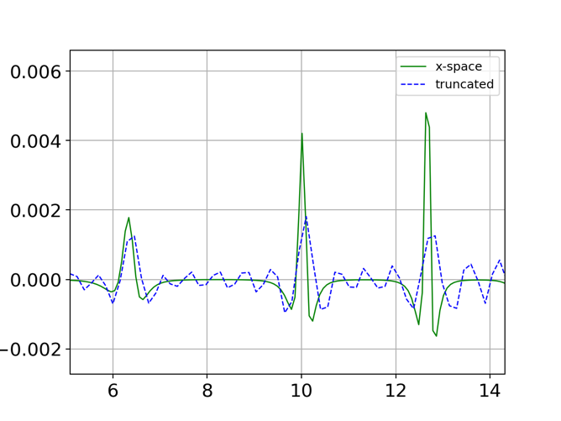

We can modify the integration code (f1d_solve_ivp) accordingly:

# Ntot diffusion

# dy = np.empty(np.shape(NQLL0))

# for i in range(1,len(NQLL0)-1):

# dy[i] = DoverdeltaX2*(NQLL0[i-1]-2*NQLL0[i]+NQLL0[i+1])

# dy[0] = DoverdeltaX2*(NQLL0[-1] -2*NQLL0[0] +NQLL0[1]) # Periodic BC

# dy[-1] = DoverdeltaX2*(NQLL0[-2] -2*NQLL0[-1]+NQLL0[0])

Dcoefficient1 = 4*DoverdeltaX2/l**2*np.pi**2; #print('Dcoefficient1', Dcoefficient1)

bj_list = rfft(NQLL0)

j_list = np.array([j for j in range(len(bj_list))])

j2_list = np.array(j_list)**2

j2_list[(j_list>100)] = 0

cj_zeroed_list = bj_list*j2_list

dy = -Dcoefficient1 * irfft(cj_zeroed_list)

But the result is terrible. On the left is the (original) x-space diffusion code, which is OK up to about 17 ms. On the right is the zeroed-out FT code, which is seen to be unstable long before that time.

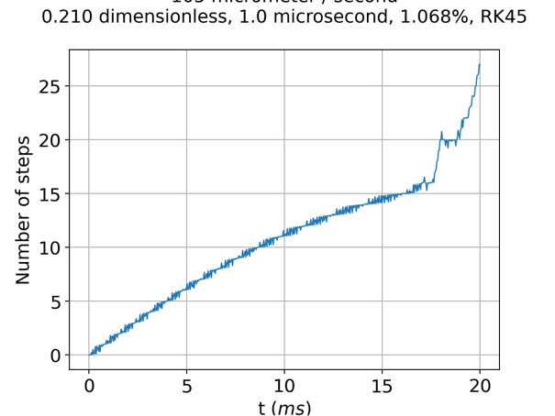 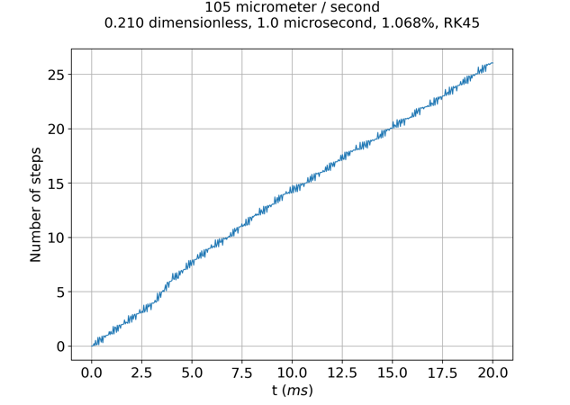

The profile is very noisy. Here are the two systems at a time of 16 ms:

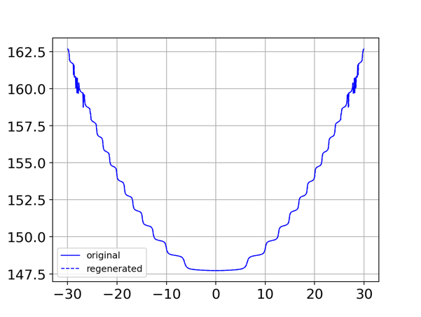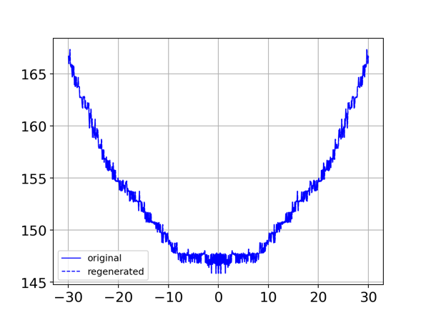

Weirdly, when we use **all** of the Fourier components, the time evolution is **even more unstable**. So the answer is, **Scheme B won’t work** for for RK45.

How about **Scheme B** with an **implicit method**? Here are parameters using odemethod=**BDF**, in which all the j-values are included. It’s a very short run (2 ms) because BDF is so slow.

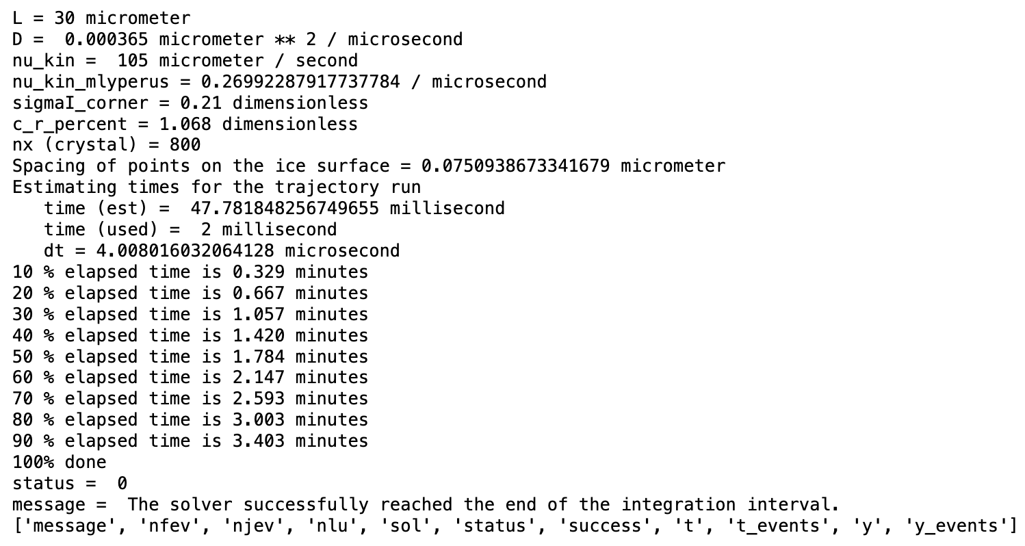

The integration goes unstable by about $1.3 ms$:

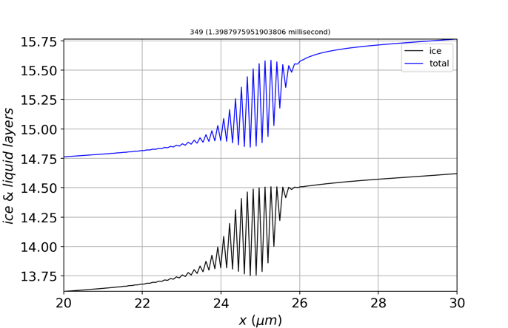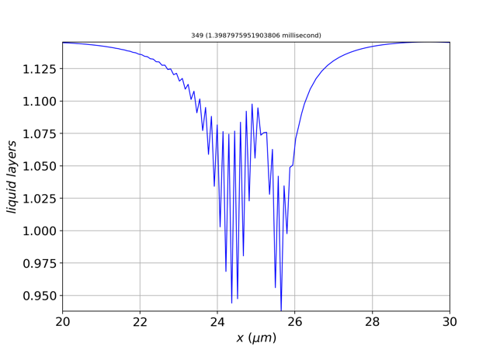

If we look at the magnitude of the glitches, we see that $N_{tot}$ and $N_{ice}$ go up and down on a scale of $±0.8$ layers, while $N_{QLL}$ goes up and down by only $±0.1$ layers.

By the time we reach $1.8 ms$, $N_{tot}$ and $N_{ice}$ go up and down on a scale of $±4$ layers, while $N_{QLL}$ still goes up and down by only $±0.2$ layers:

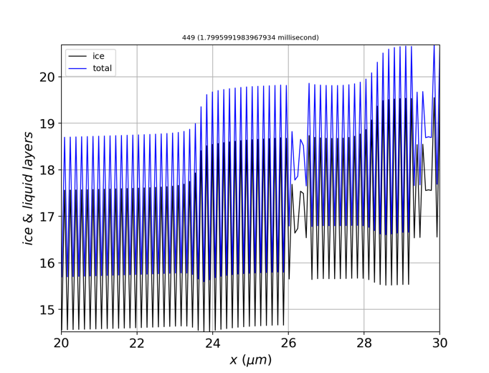 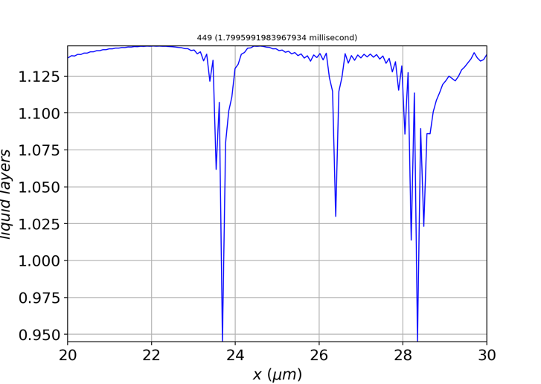

Of course, the small range of $N_{QLL}$ glitchiness is due the fact that $N_{QLL}^{eq}$ is sinusoidal, with a variability of $N^{*}=0.14$ layers.

Here’s how the glitchiness is evolving:

* At time $1.28 ms$, there’s obvious instability at the riser between 13 and 13.5 layers. By the time we get to $1.31 ms$, that instability is still there. By the time we reach $1.33 ms$, it has disappeared because it has merged with its mirror image on the other side (not shown).
* By contrast, at time $1.28 ms$ there’s no evident instability at the riser between 14 and 14.5. By $1.31 ms$, it’s clearly there, and by $1.33 ms$ it’s a lot worse.

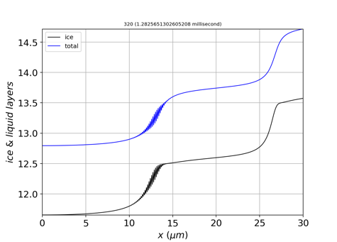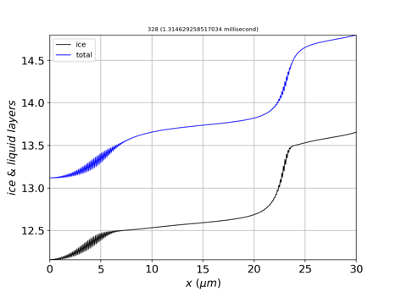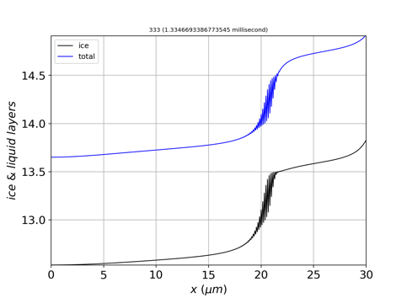

From results below at $1.29 ms$, we see that the glitchiness in $N_{tot}$ is $±0.2$ layers, much bigger than the glitchiness in $N_{QLL}$ of $±0.03$ layers

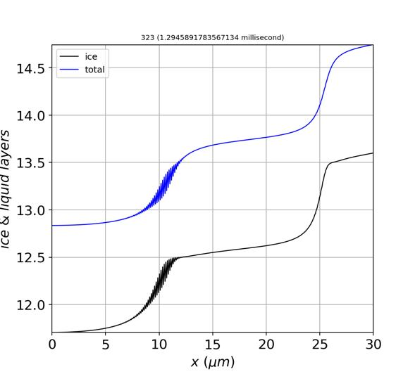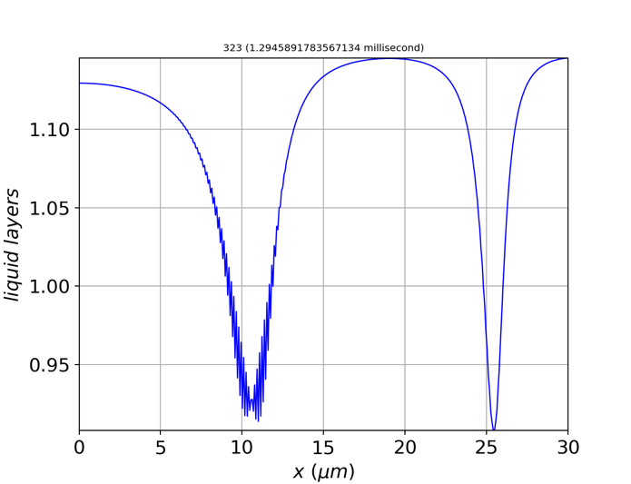

Observations … the trouble is

* associated with risers, rather than steps.
* not a result of boundary conditions.
* more pronounced for $N_{tot}$ (and $N_{ice})$ than for $N_{QLL}$.

These observations point to a problem with $μ$ surface I (because the instability occurs at a **riser** rather than at a step), and with the **diffusion** and/or the **deposition** term (i.e., ${D=D}_{QLL}∇^{2}N_{QLL}$ or $ν_{kin}σ_{m}$.

How to distinguish these? When I replicate the above (BDF) run but with a truncated $D$, the instability is more pronounced. For example, at time step 323 (displayed above), we have the full j-spectrum result on the left, and the truncated result ($D\left(J>100\right)=0$) on the right.

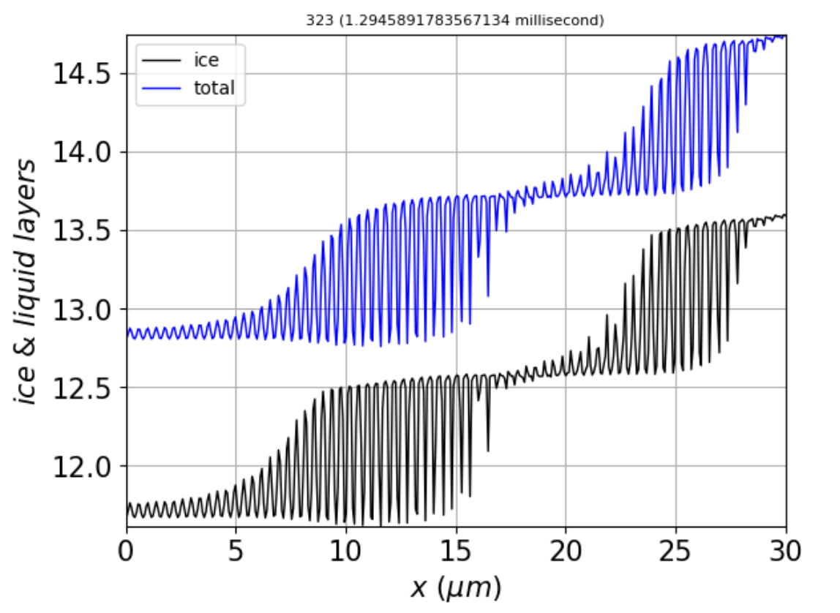

Because these results appear with a Fourier representation of the diffusion term (Scheme B), this points to a problem with the deposition term, $\frac{{∂N}_{tot}}{∂t}=D_{QLL}∇^{2}N_{QLL}+ν_{kin}σ_{m}$.

We said before that, using RK45, **increasing the diffusion coefficient would make things less stable**. That’s still the case with BDF. Below on the **left** is the **BDF** run with the following parameters (bigger D). On the **right** is **RK45** run with the same parameters. This the result at $2 ms$.

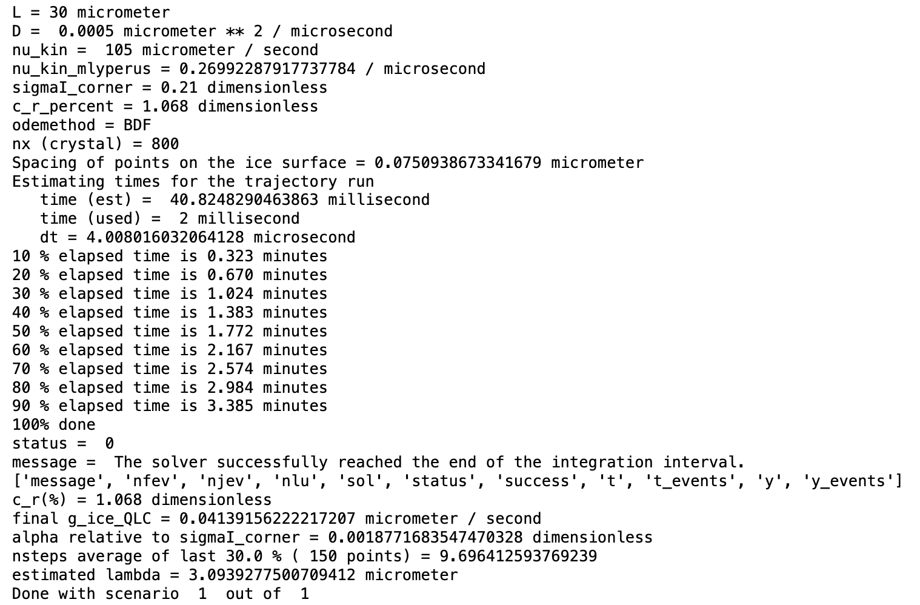

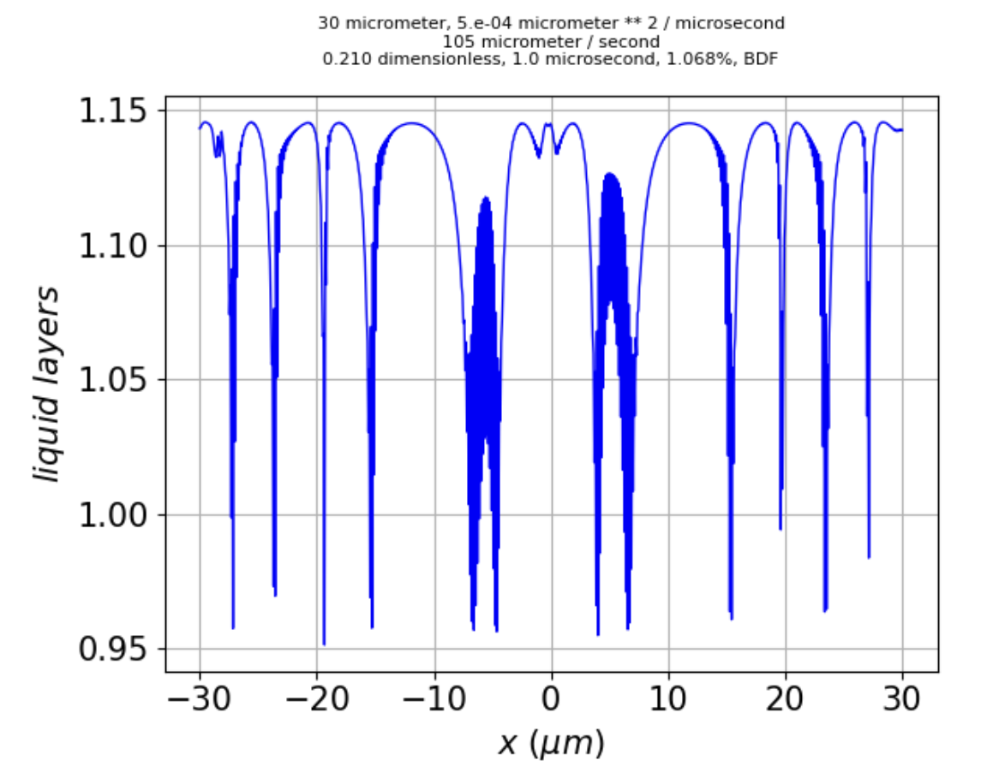 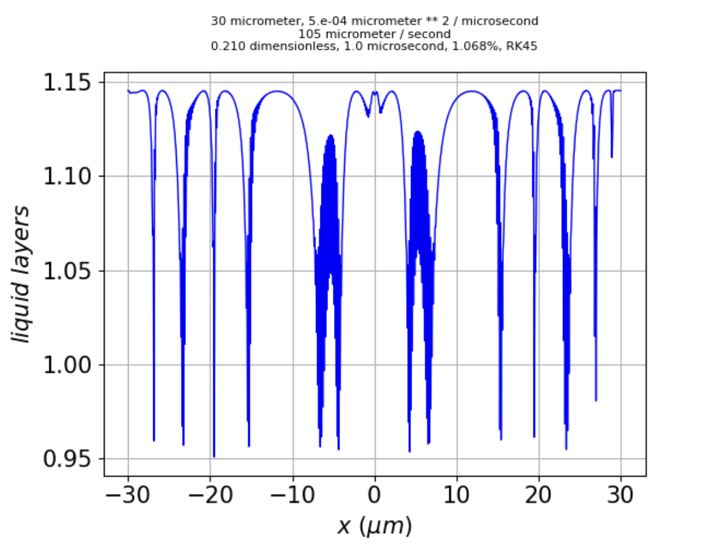

What $N_{QLL}$ seems to be telling us here – and it is consistent between two different integration methods (BDF and RK45) – is that there is a **characteristic distance** (here about $5 μm$) between parts of the surface that look like $μ$ surface I, separated by longer stretches that look like $μ$ surface II. Is this the manifestation of an onset of roughness? If we look at

$N_{tot}$, we see that there are much bigger jumps, in this case spanning over twenty layers. That’s consistent with the onset of roughness, the only “problem” now being that these vast changes in $N_{tot}$ are occurring **right next to one another**, rather than at the characteristic distance suggested by the separation between portions that look like $μ$ surface I.

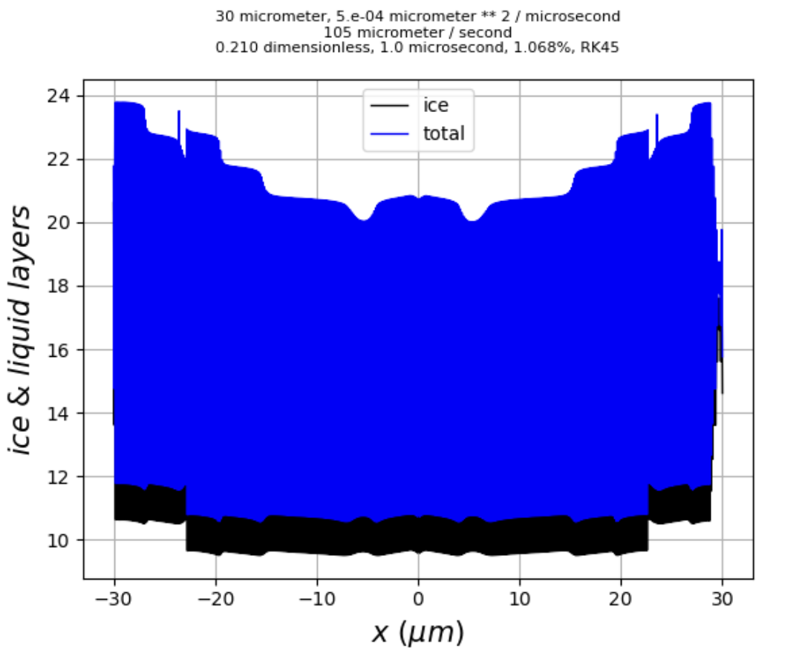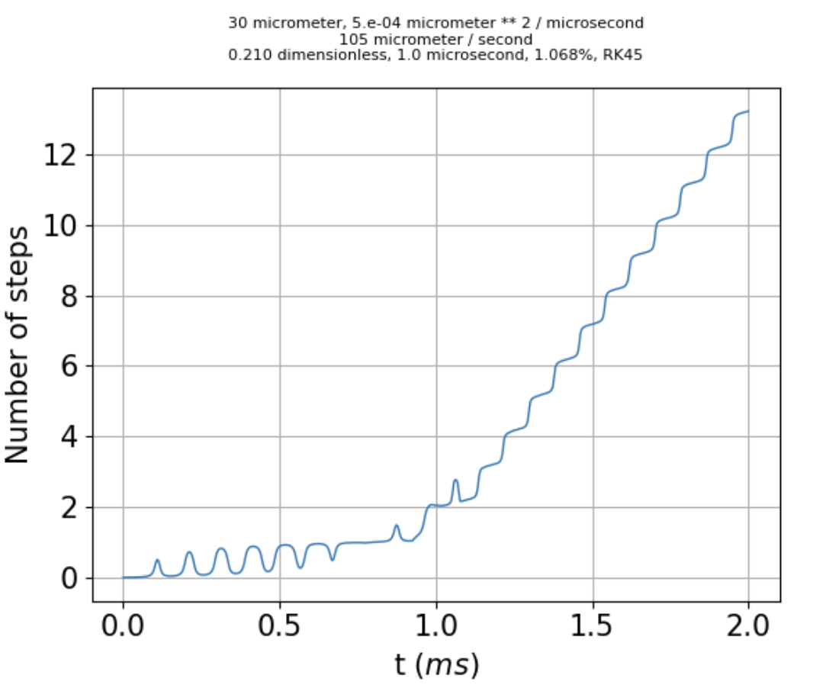

Adding a second facet plane.

$$z$$

$$x$$

The lines indicate prismatic layers (blue) and pyramidal layers (red), with an angle $θ$ between them ( $28°$ if these were truly prismatic and pyramidal). Applying a rotation, we have

$z_{py}=c_{θ}z_{pr}±s_{θ}x$ (13)

where the negative sign applies to the situation shown, and the positive sign would apply to red lines sloping down instead of up. Heights above a reference point are

$z_{pr}=h_{pr}N_{tot,pr}$ (14)

$z_{py}=h_{py}N_{tot,py}$ (15)

which means

$N_{tot,py-}=\frac{1}{h_{py}}\left(c_{θ}h_{pr}N_{tot,pr}-s_{θ}x\right)$ (16a)

$N_{tot,py+}=\frac{1}{h_{py}}\left(c_{θ}h_{pr}N_{tot,pr}+s_{θ}x\right)$ (16b)

We need to decide which of these formulas applies in determining the equilibrium quasi-liquid thickness, $N_{QLL}^{eq}(N_{tot})$. Here I propose a step function that depends on the slope of our surface, $β≡\frac{dz}{dx}$, for example,

$α(β)={1-\left(1+e^{-\frac{β-β_{trans}}{∆β}}\right)}^{-1}$ (17)

which looks like

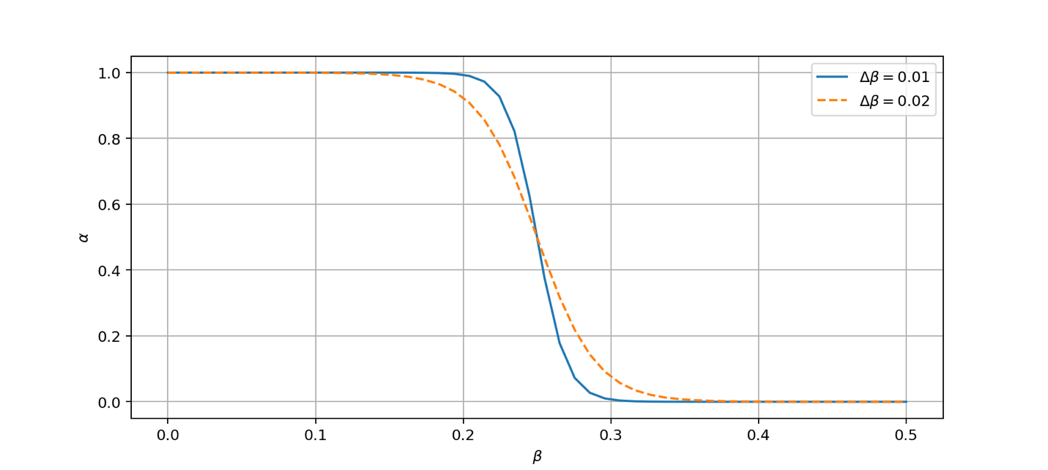

where $β_{trans}$ is the midpoint of the transition and $∆β$ controls the abruptness of the transition. Then we can represent an analytical transition from one facet regime to another.

A couple of quantitative questions:

1. What’s a reasonable value for $β_{trans}$? Half-way from prismatic to pyramidal, we have a slope $\frac{dz}{dx}=\frac{s_{θ/2 }}{c_{θ/2}}≈0.25$. So we can say $β_{trans}=0.25$.
2. How much of a step in $N_{tot,pr}$ does this value of $β_{trans}$ correspond to? We have ${∆N}_{tot,pr}=\frac{dN_{tot,pr}}{dx}∆x=\frac{1}{h_{pr}}\frac{dz}{dx}∆x$, so at the transition, with $\frac{dz}{dx}=0.25$, a grid spacing (in the GrowthInstability code) of $∆x=0.075 μm$, and a lattice depth of $h_{pr}=0.389 nm$, we get ${∆N}_{tot,pr}=48$ layers. With parameters set in GrowthInstability as

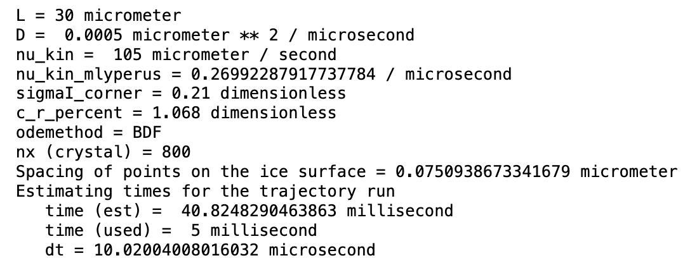

after $5 ms$ we get these results:

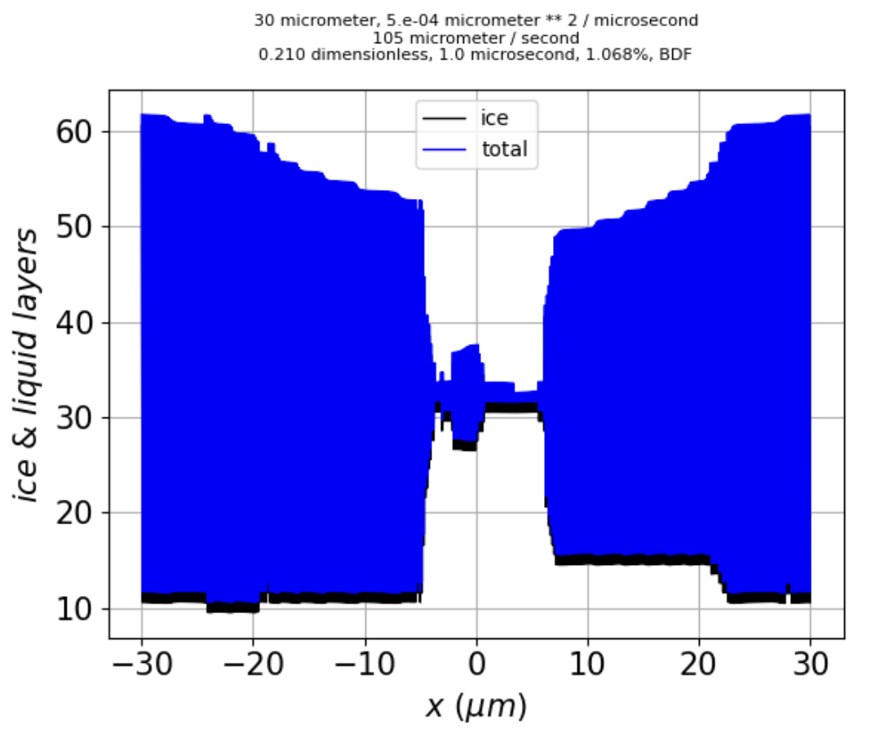 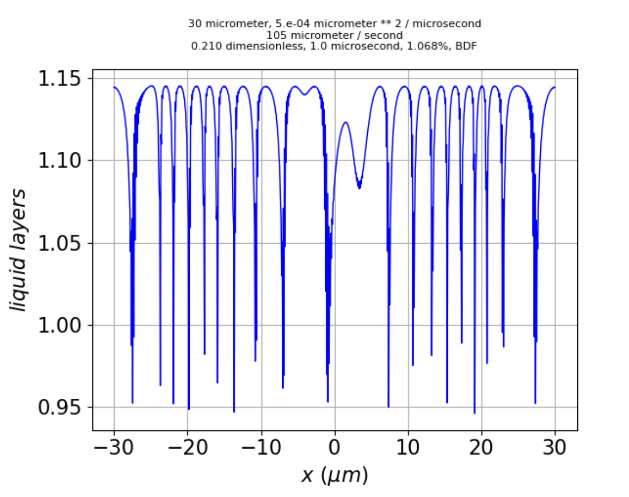

Some additional comments …

* Since RK45 produces pretty similar results, I have some confidence in their replicability.
* It’s unfortunate (but not invalidating) that we’ve drifted from symmetry across $x=0$.
* As previously, the extreme fine-scale variability in $N_{tot,pr}$ ( $±50$ layers) is hard to interpret; however, $N_{QLL}$ displays an obvious length scale of $2$ to $6 μm$.

Before moving on to implementation, the following question arises: Are there other parameters (apart from those mentioned on page 3) that we would want to transition? Here’s a comparison (all RK45 runs, but BDF are similar):

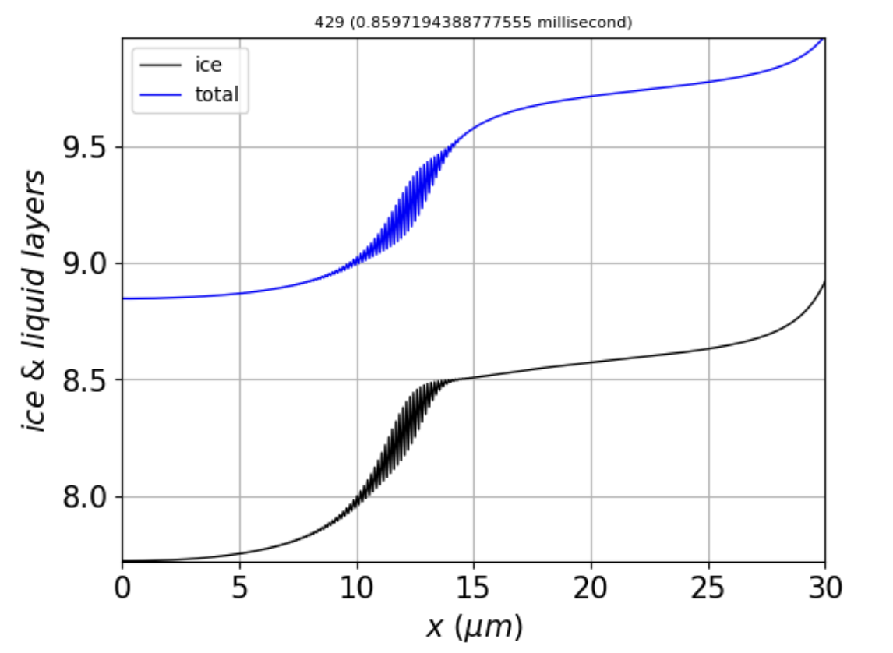 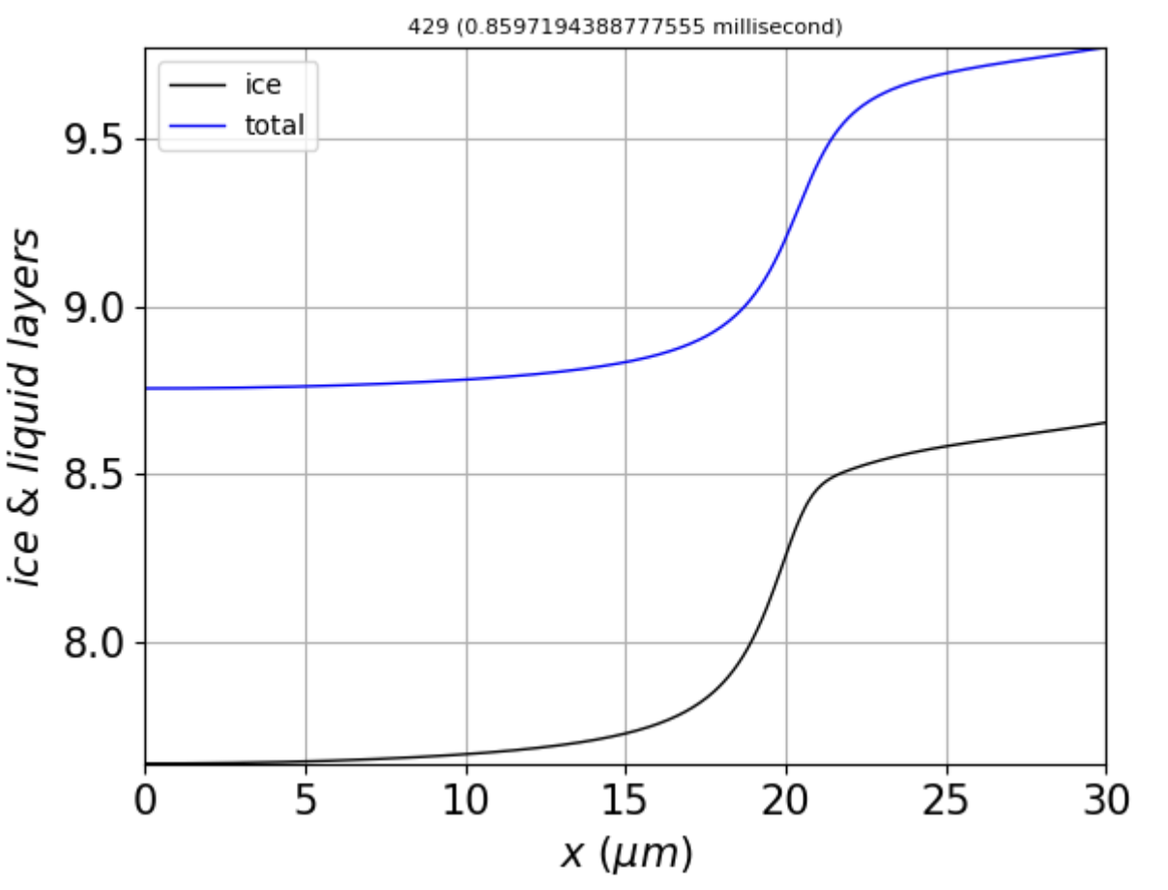 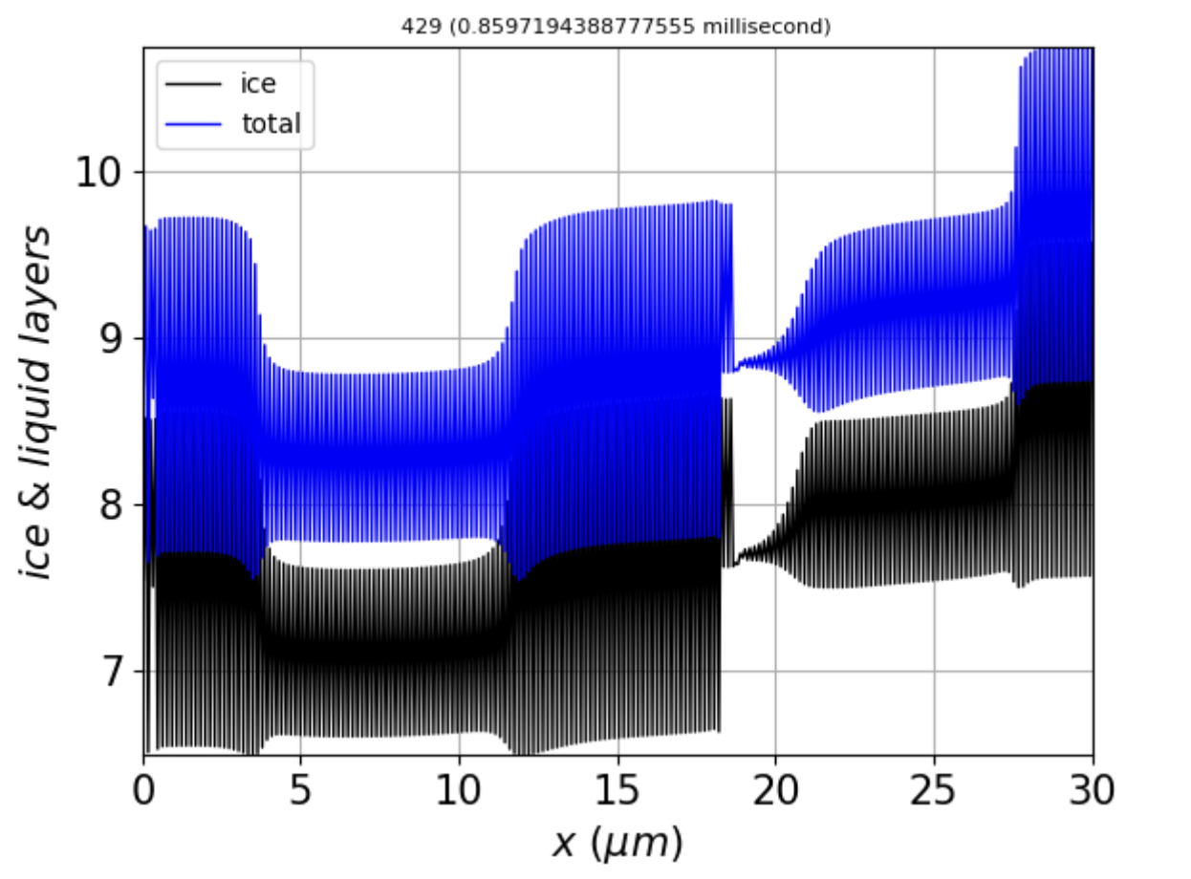

Left: Standard parameters; middle: $N^{*}$ reduced by $20\%$; $N^{*}$ increased by $20\%$.

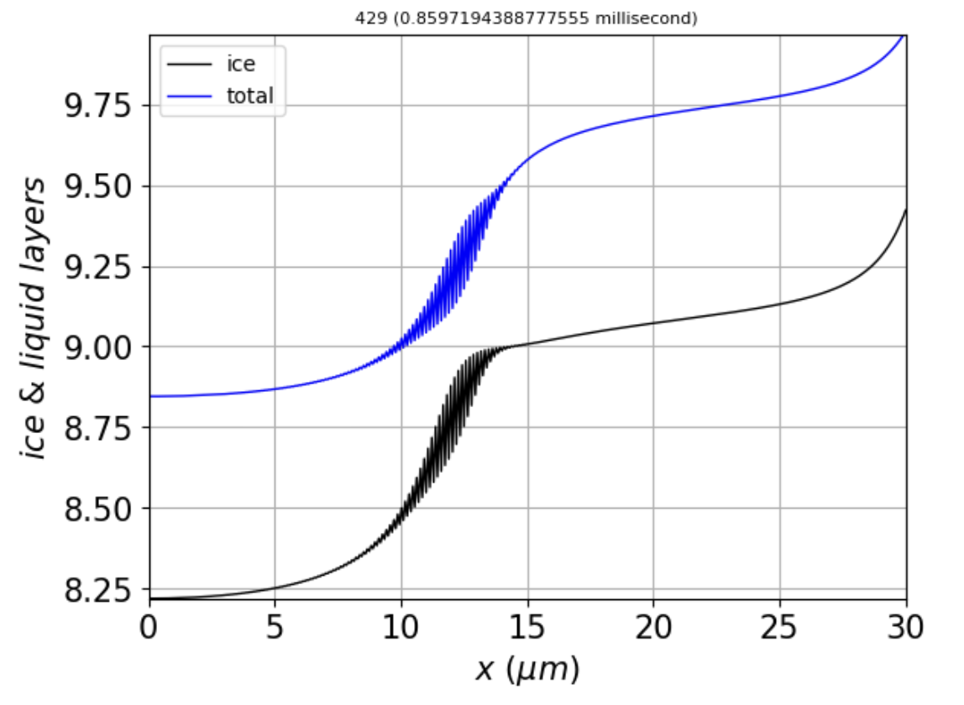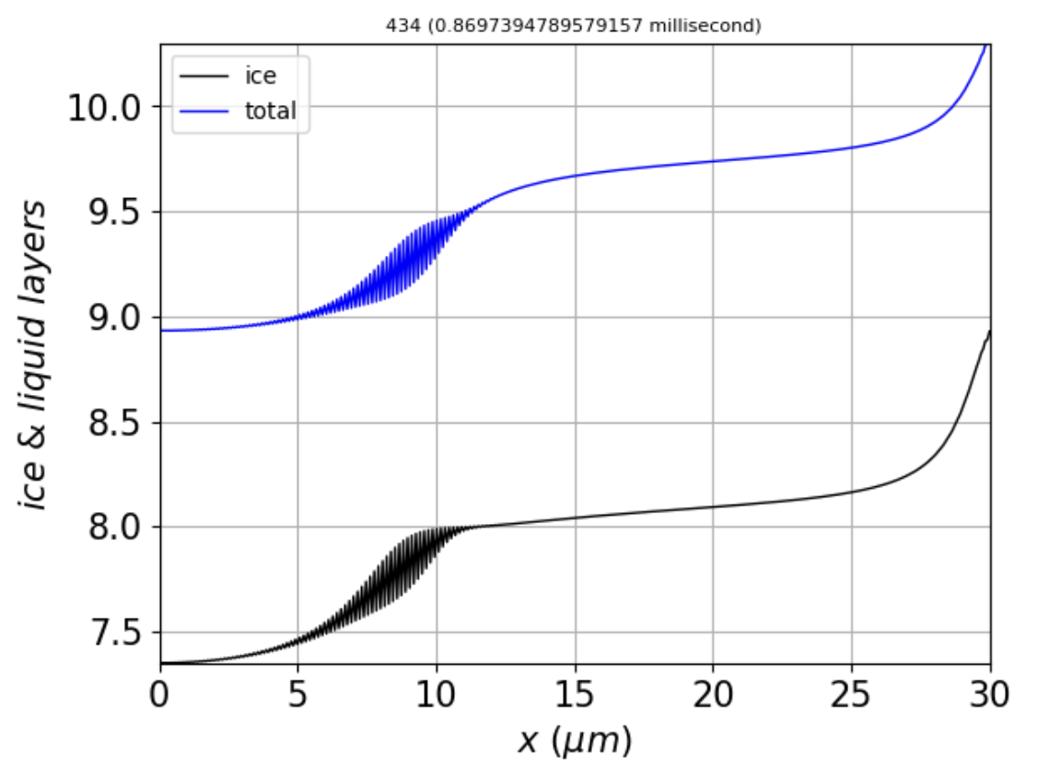

Left: Standard parameters; middle: $\overline{N}$ reduced by $50\%$; $\overline{N}$ increased by $50\%$.

Conclusions:

* Stability is favored by smaller $N^{*}$.
* Stability is not a strong function of $\overline{N}$.

**Transitioning**. We can use the above to construct a set of weights $α$:

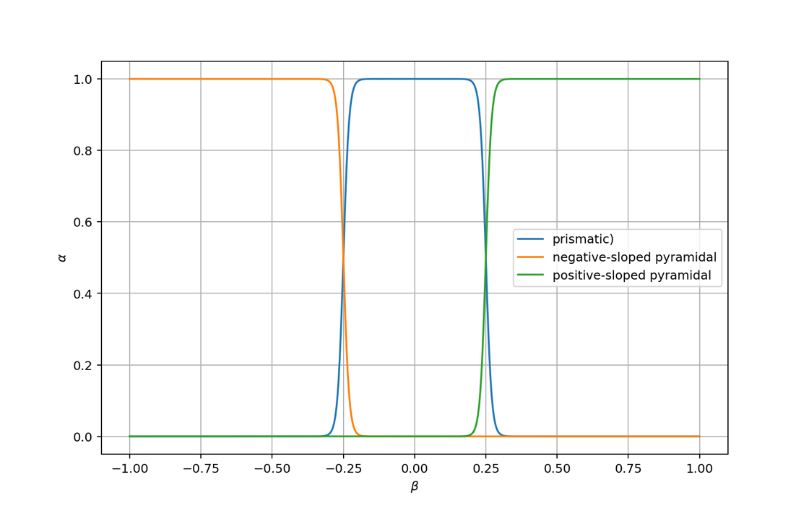

so that pixels that have a strong negative slope ($β≪-0.25$, for example) are assigned $α_{py-}≈1$, with $α_{py+}≈α_{pr}≈0$, but pixels with weak slope ($-0.25<β<0.25$) are assigned $α_{pr}≈1$, with $α_{py+}≈α_{py-}≈0$, and so on (see figure above). Then from three quasi-liquid equilibration functions,

$N_{QLL,pr}^{eq}=N_{pr}-N_{pr}^{*}\sin\left(2πN_{tot,pr}\right)$ (18a)

$N_{QLL,py-}^{eq}=N_{py-}-N_{py-}^{*}\sin\left(2πN_{tot,py-}\right)$ (18b)

$N_{QLL,py+}^{eq}=N_{py+}-N_{py+}^{*}\sin\left(2πN_{tot,py+}\right)$ (18c)

we construct

$N_{QLL}^{eq}=α_{py-}{×N}_{QLL,py-}^{eq}+α_{py+}{×N}_{QLL,py+}^{eq}+α_{pr}{×N}_{QLL,pr}^{eq}$ (19)

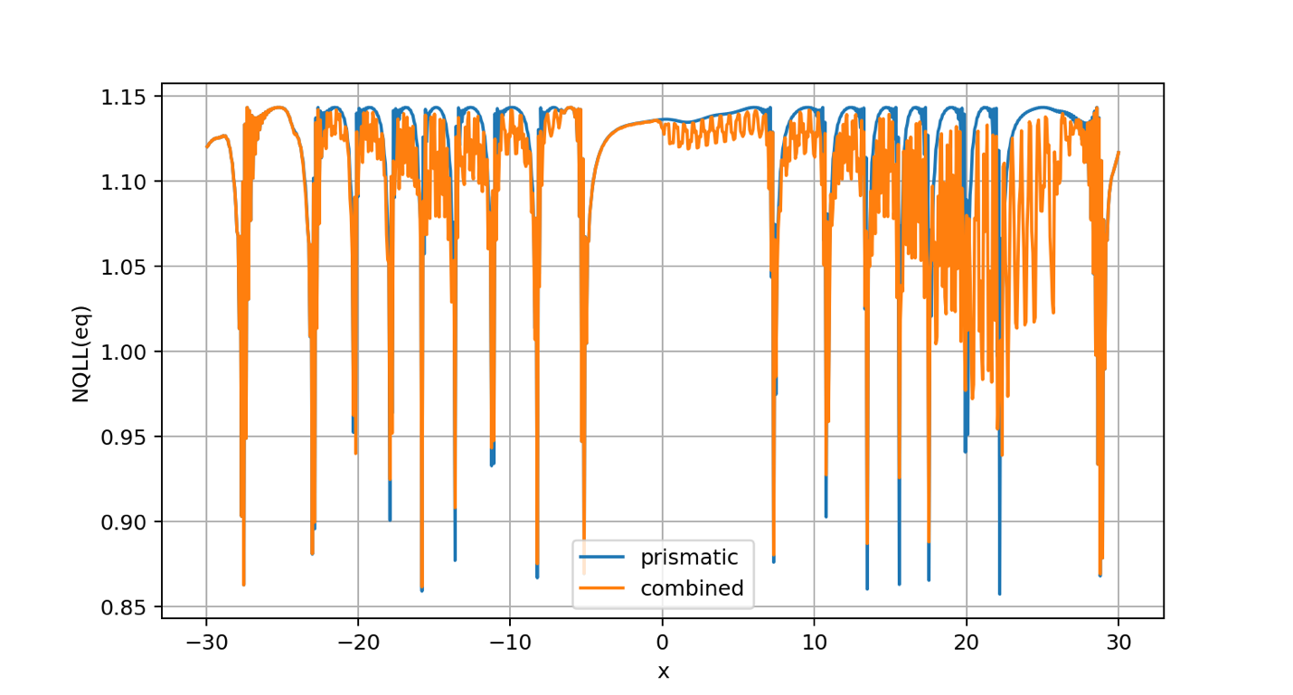

OK, putting a hold for the time being on the glitch business. Since **larger $τ$**  and **smaller $n_{x}$**  tend to favor stability, what do we see? Here’s a run that shows the formation of a **stable** **rim**:

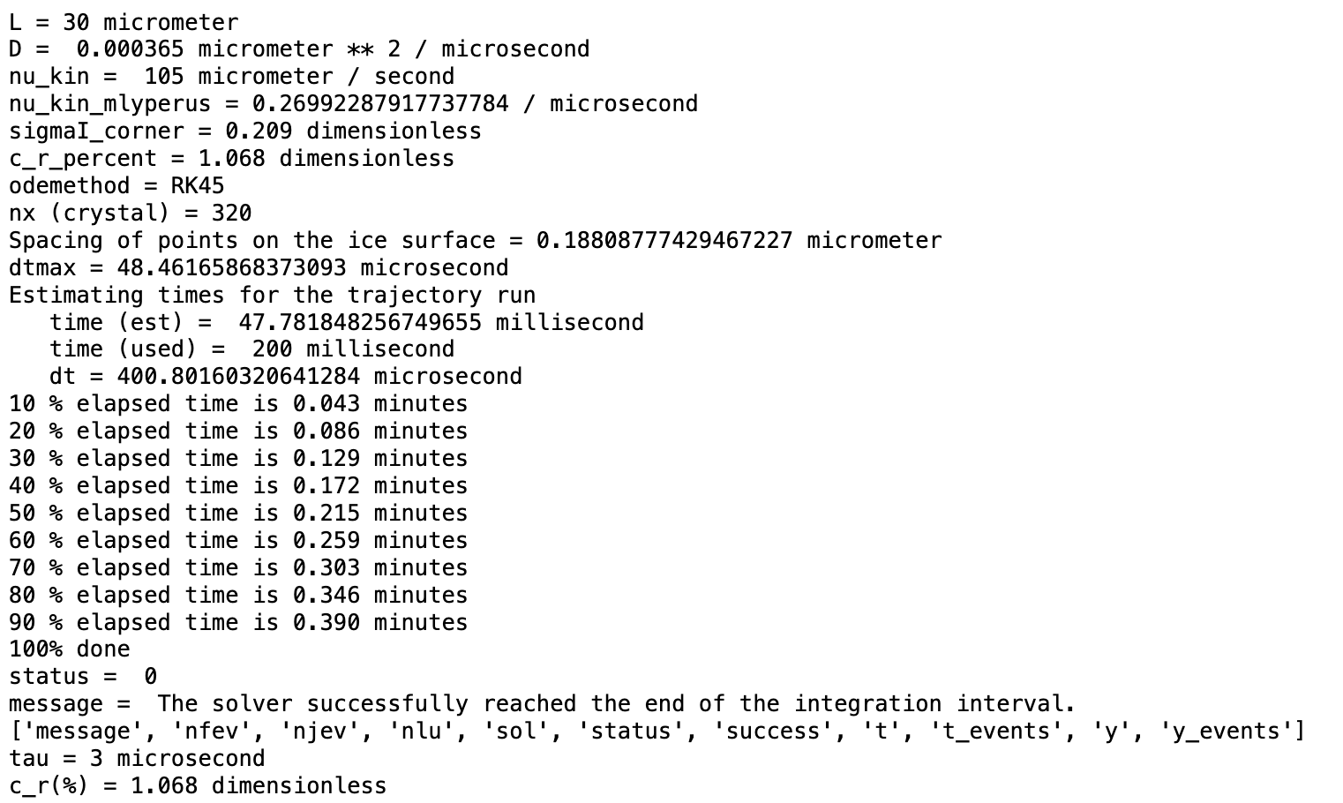

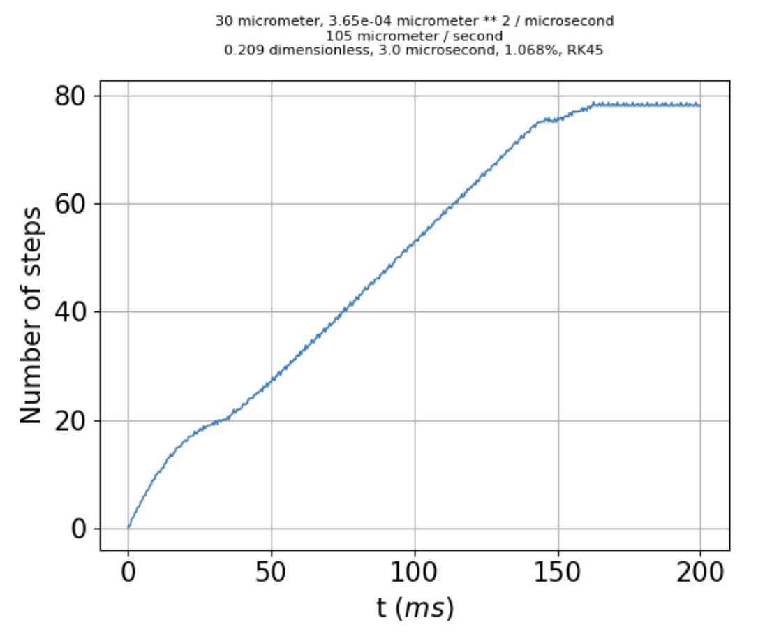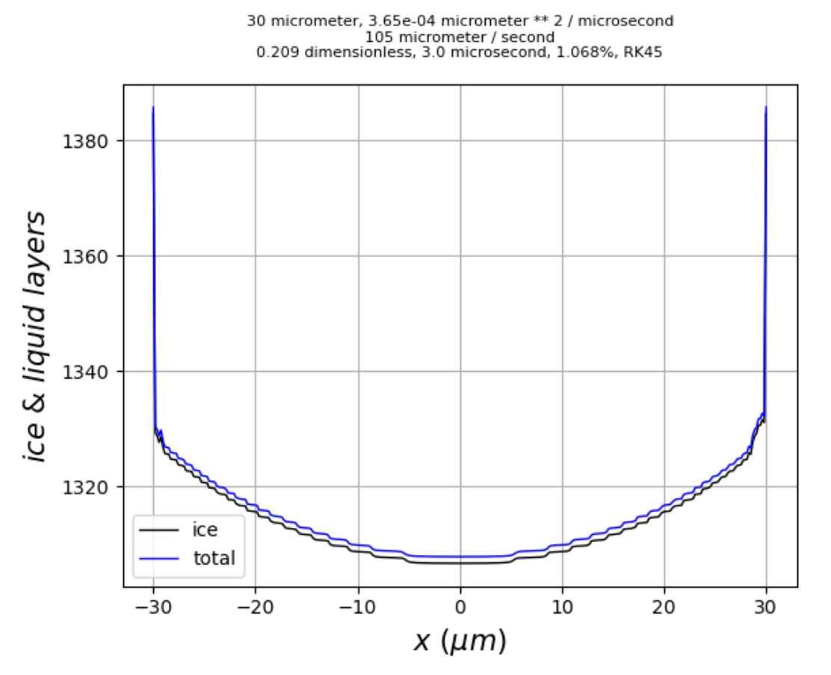 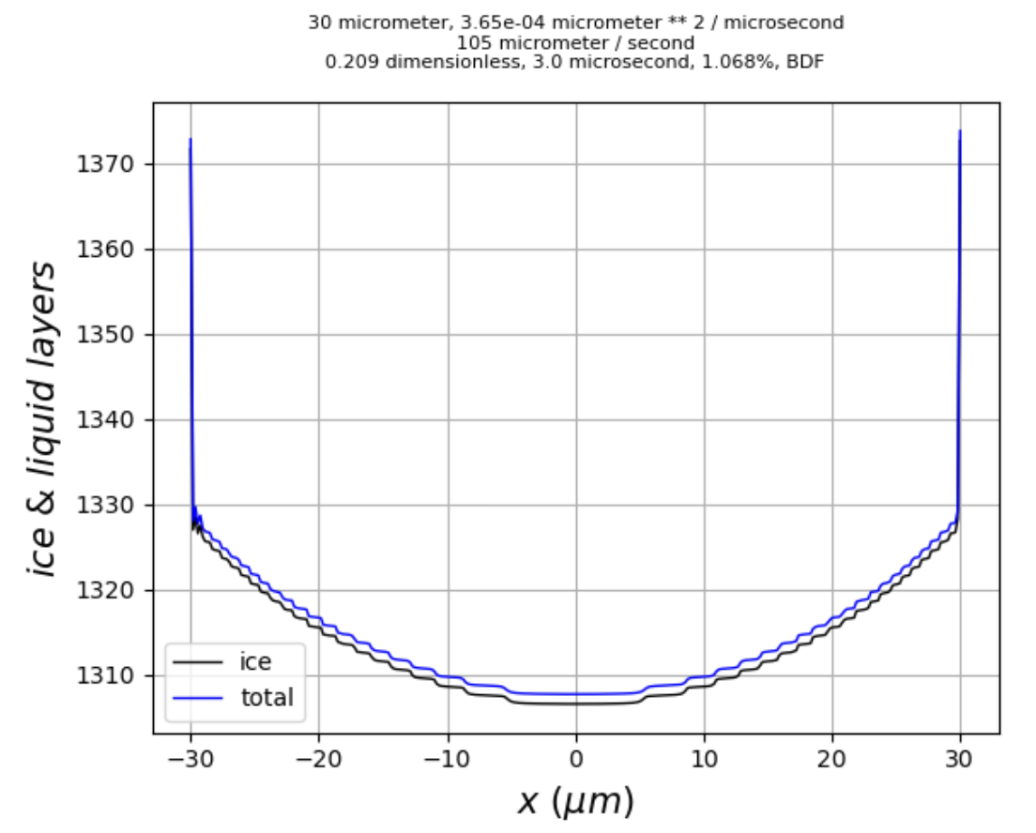

The first two images above are RK45 results; as shown on the right, the results are very similar using BDF.

A rim of 60 layers would have a physical dimension of $\sim 0.02 μm$, which would be not quite detectable in an SEM image. However, I would argue that **rimming** is the precursor to **hollowing**.

The steady state character is very tenuous, however: If sigmaI_corner is reduced just from 0.209 to 0.208, growth at the corners continues indefinitely:

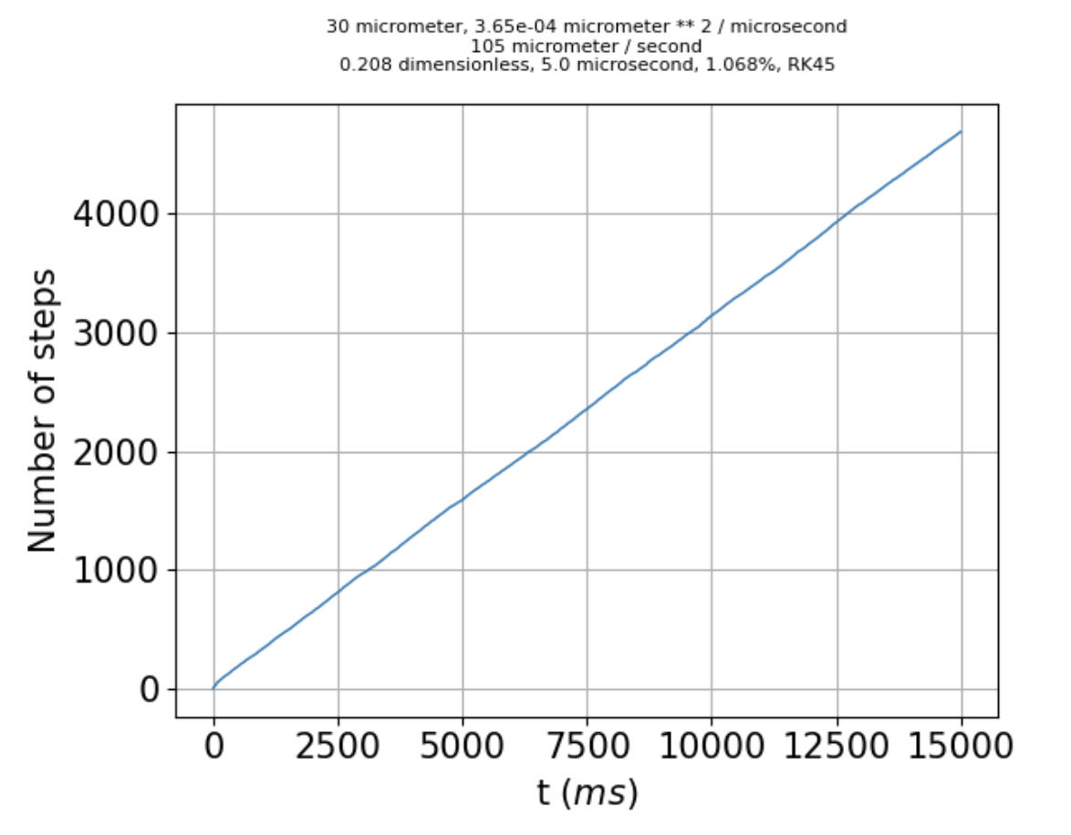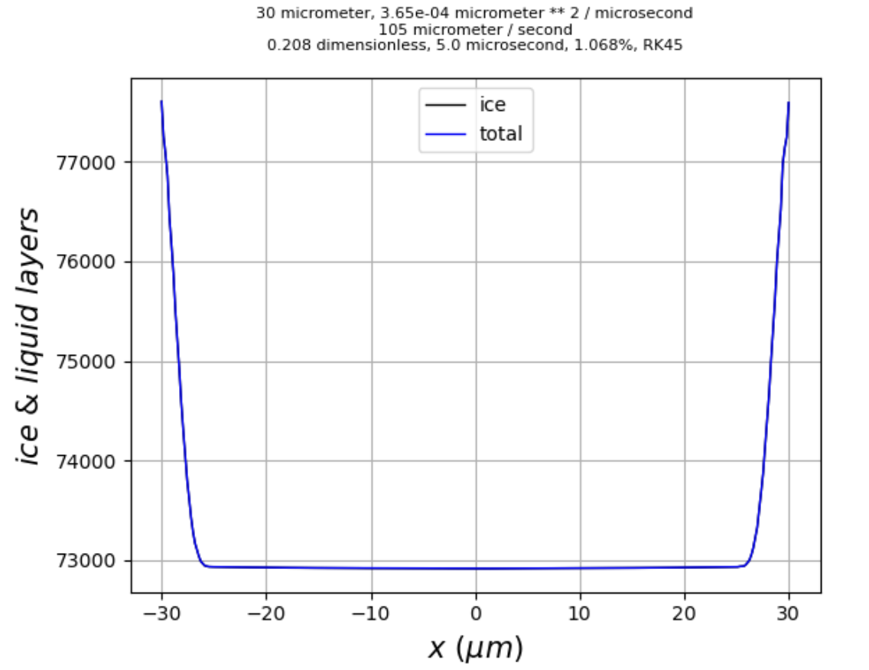

The excess 4500 layers at the corners would stick out about $\sim 2 μm$, which *would* be visible on an SEM scale.

This scenario also exhibits the possibility of **stabilization due to a $28°$ facet**. How do we know that? At $15,000 ms$, this run produces the following angles ($θ$), facet probabilities ($α$), and quasiliquid thicknesses:

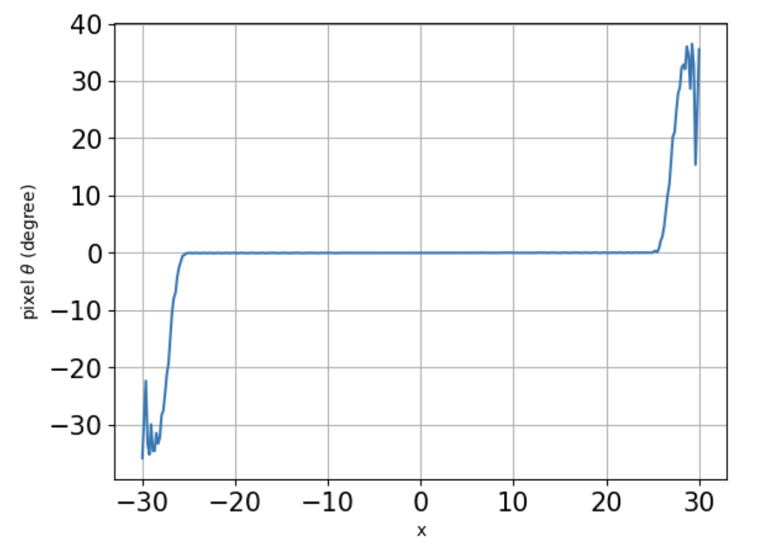 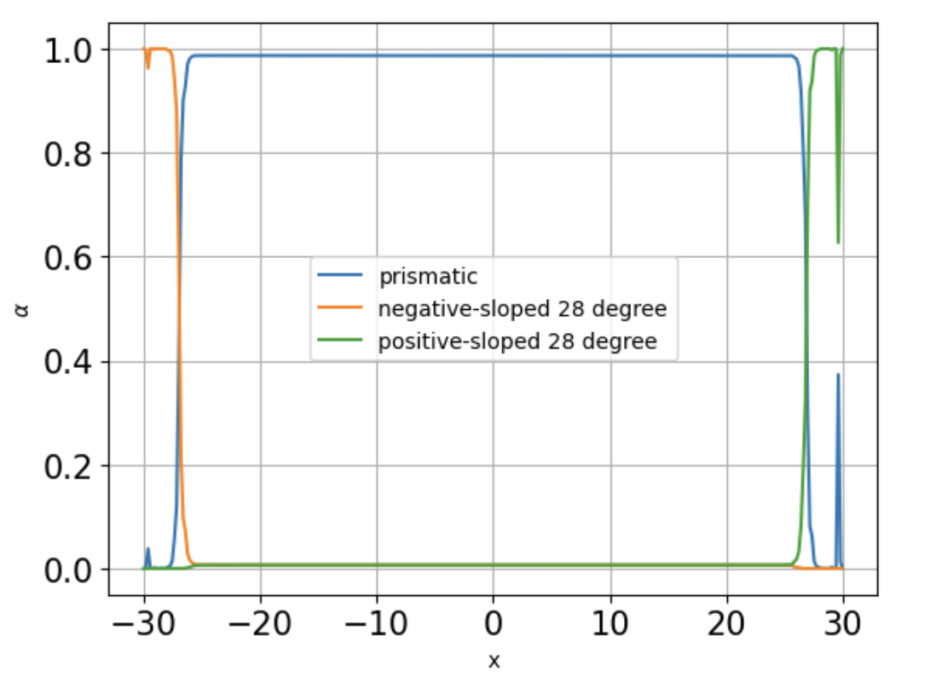 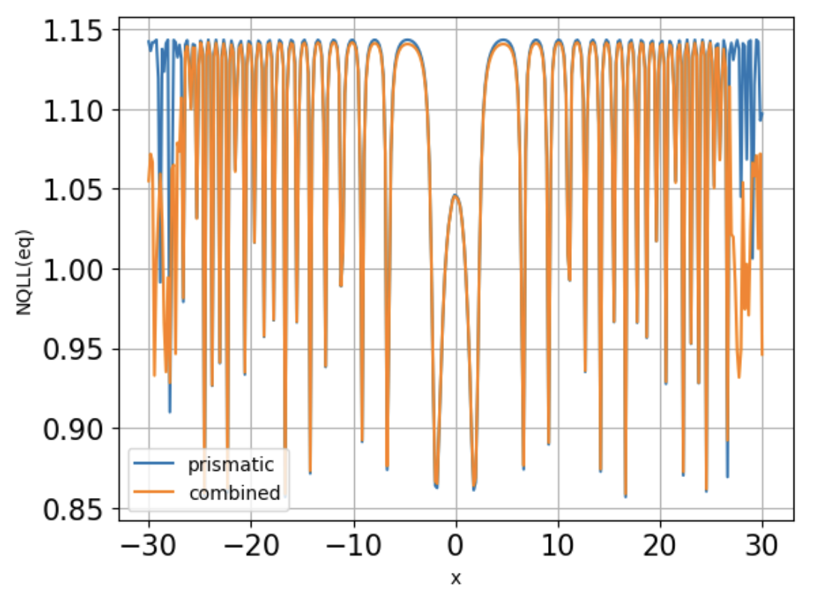

These graphs are diagnostic only. The point is, if a provision for pyramidal faceting were encoded, the surface near the corners would (I think) switch to it.

Another prediction relates to the supersaturation. Our theory says $m=\frac{N_{QLL}-\left(\overline{N}-N^{*}\right)}{2N^{*}}$, and $σ_{m}(x) =σ_{I}(x)-mσ^{o}$. Below we plot $σ_{m}(x)$ for the current run (at $15 ms$), and that predicted by

$m'=\frac{N_{QLL}-\left(\overline{N}-N^{*}(x)\right)}{2N^{*}(x)}$ (20)

where

$N^{*}\left(x\right)=α_{py-}N_{py-}^{*}+α_{py+}N_{py+}^{*}+α_{pr}N_{pr}^{*}$ (21)

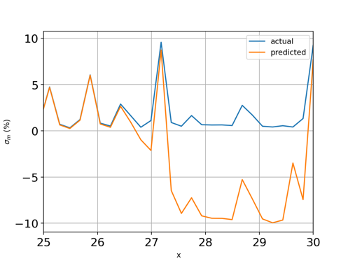

What does it mean? Starting from the right-hand corner and moving to the left,

* a **rim** at $x≈30 μm$, followed by
* a **pyramidal** **pit** from $-27.5<x<30$, followed by
* a **peak** **farther** **in** ($27<x<27.5 μm$), followed by
* business as usual (prismatic) farther in ($x<27 μm$)

OK, implementing the above, step by step, starting with Eq. 20. Below at left is the original formulation ($N_{py±}^{*}=N_{pr}^{*}$), at right with reduced QLL thickness for the QLL ($N_{py±}^{*}=N_{pr}^{*}/2$), both taken out to 15,000 ms. We can see that the result is a big slow-down in the corners, even though the angles achieved are very modest departures from flat (third figure).

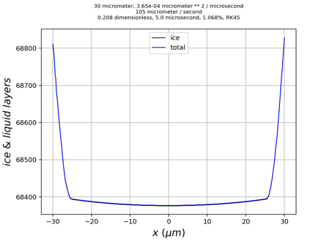 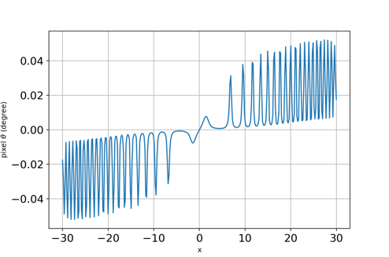

**BDF** runs appear to be taking about 10x as long as **RD45**, by the way.

In order to accommodate the possibility of different threshold vapor pressures, I can’t use Eqs. 20 and 21. Instead, I’ve implemented

$m_{pr}=\frac{N_{QLL}-\left(\overline{N}-N_{pr}^{*}(x)\right)}{2N_{pr}^{*}(x)}$, $σ_{m,pr}(x) =σ_{I}(x)-m_{pr}σ_{pr}^{o}$ (22a)

$m_{py}=\frac{N_{QLL}-\left(\overline{N}-N_{py}^{*}(x)\right)}{2N_{py}^{*}(x)}, σ_{m,py}(x) =σ_{I}(x)-m_{py}σ_{py}^{o}$ (22b)

and used the weights to construct a position-dependent supersaturation,

$σ_{m}\left(x\right)=α_{py-}σ_{m,py}(x)+α_{py+}σ_{m,py}(x)+α_{pr}σ_{m,pr}(x)$ (23)

which goes into the deposition term, $σ_{m}(x) =σ_{I}(x)-mσ^{o}$. I’ll call Eqs. 18, 22, and 23 the “polymicrofacet formulation.” How does the polymicrofacet formulation do numerically? Here’s a set of parameters (except the tau value was overridden, to 5 microseconds):

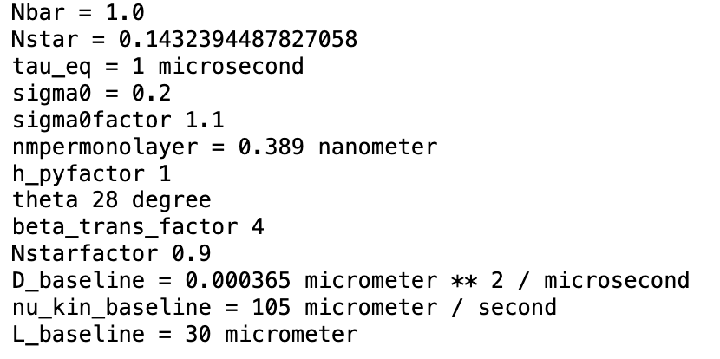

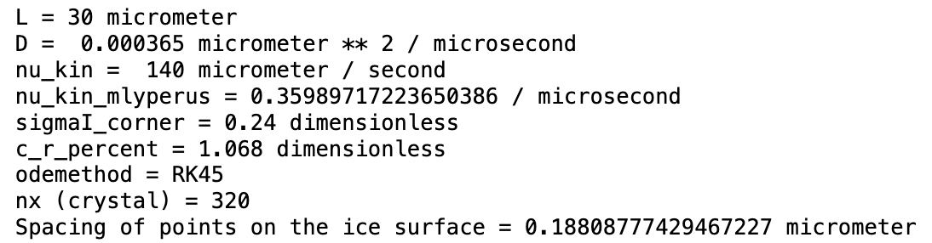

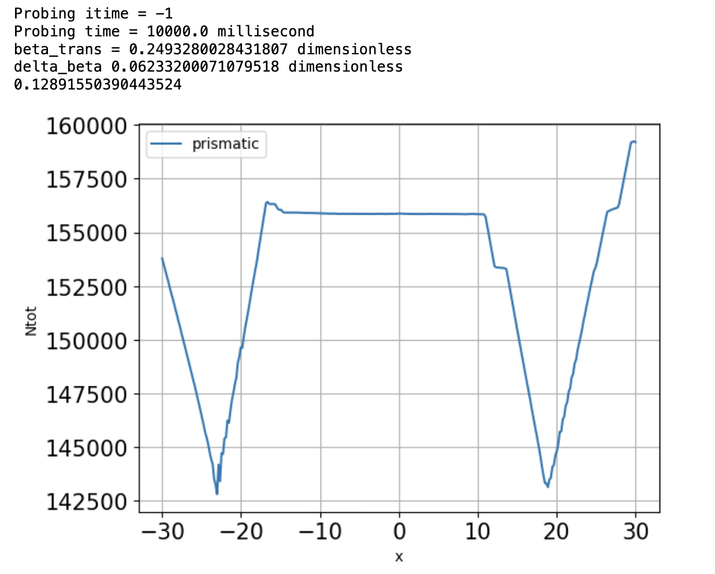

And here are some results:

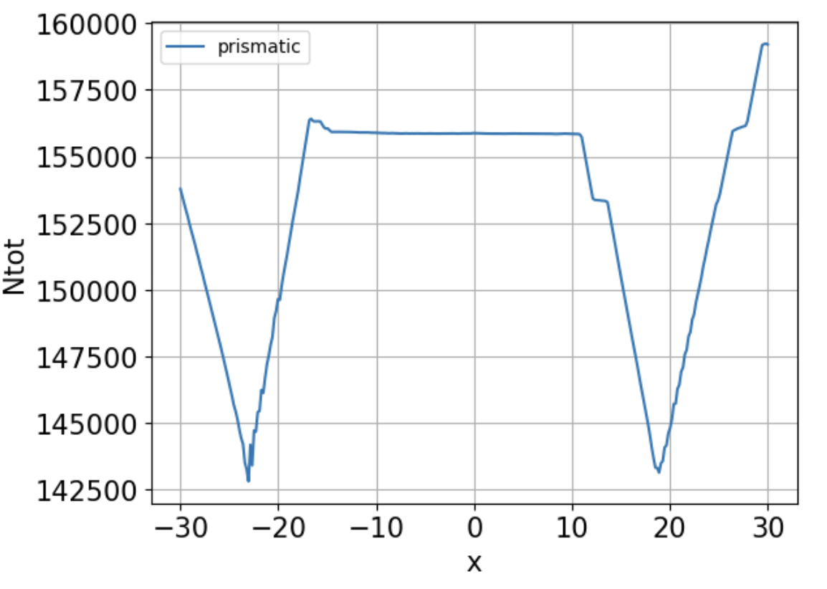 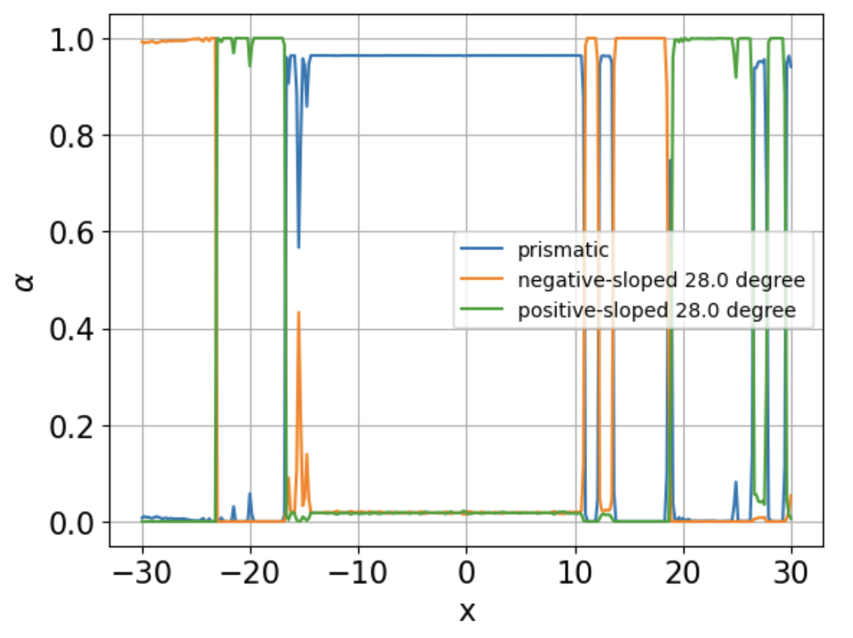 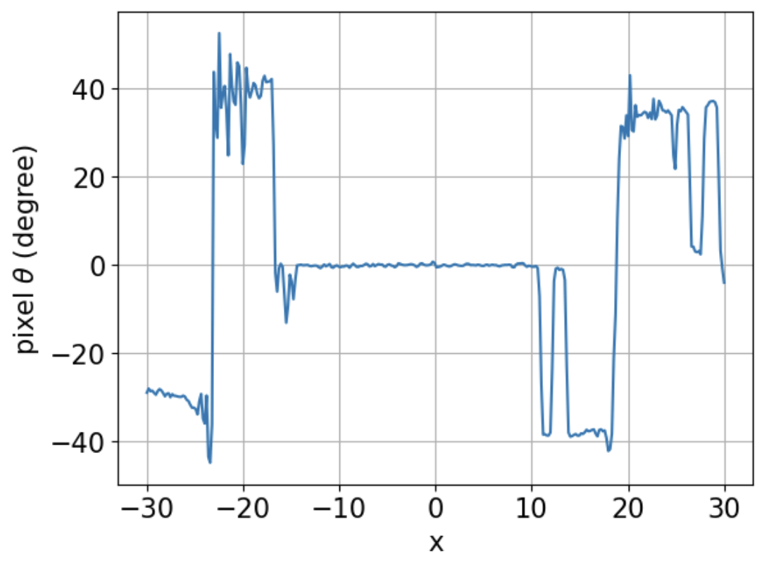

What does it mean? On the left, we see a rough surface, with contiguous sections identifiable as pyramidal and prismatic. The prismatic-dominated section in the middle is bounded on each side by deep ($5 μm$) pyramidal crevices, separated horizontally by $\sim 40 μm$. Other features are spaced more closely in both the horizontal and vertical directions. The pyramidal parts of the surface have angles deflected from horizontal in the range $30°-40°$ for the most part ( $28°$ is expected).

How do these scales compare with experiment? Typical SEM roughness has vertical relief on the order of $<1 μm$, and horizontal spacing on the order of $\sim 5-10 μm$.

Some questions I’d like to resolve:

1. Is the polymicrofacet formulation still capable of faceted growth over the entire surface?

The answer is “yes.” When the same parameters as above are used, except that $c_{r}$ is reduced from $1.068 \%$ to $0.5 \%$, the system convincingly reaches a steady state after $800 ms$:

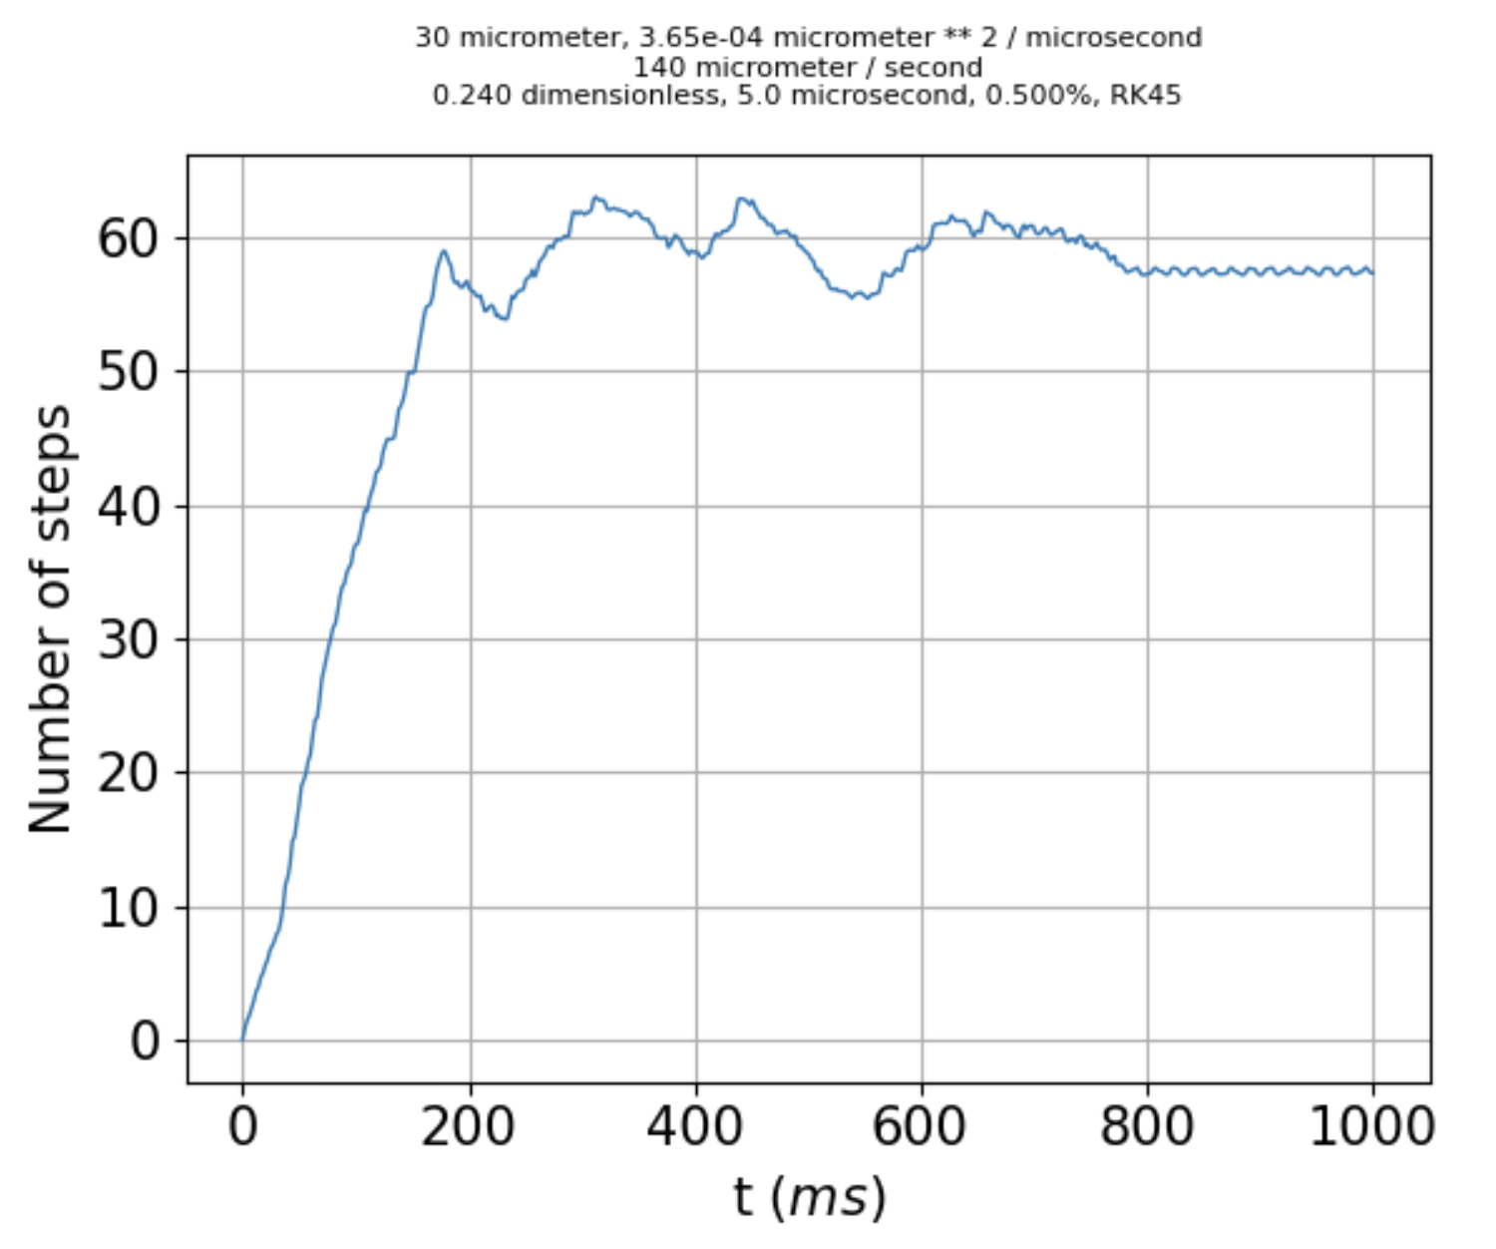

1. Why is the symmetry broken?

Here’s one possibility: the diffusion term is calculated using the discrete FT of $N_{QLL}(x)$, which assumes periodic boundary conditions. But that means the last item in $N_{QLL}(x)$ is *not the same as the first item*. However, when I tried to correct for that by defining

x_QLC_long = np.linspace(-L,L,nx_crystal+1)

x_QLC = x_QLC_long[1:]

…

sigmaI_QLC = sigmaI_corner*(c_r*(x_QLC/L)**2+1-c_r)

the result was still messy and asymmetrical.

So, it’s still a mystery why the symmetry is broken. One consolation: the symmetry breaking occurs only after very long times, like thousands of milliseconds.

1. What determines the horizontal and vertical spacing between microfacets?

As for the third question, it will take time to chase down all the possibilities.

What's the effect of the microfaceting? On the left below is the prismatic-only code results after 1000 ms. This pattern just keeps getting more and more extreme; it’s basically rimming.

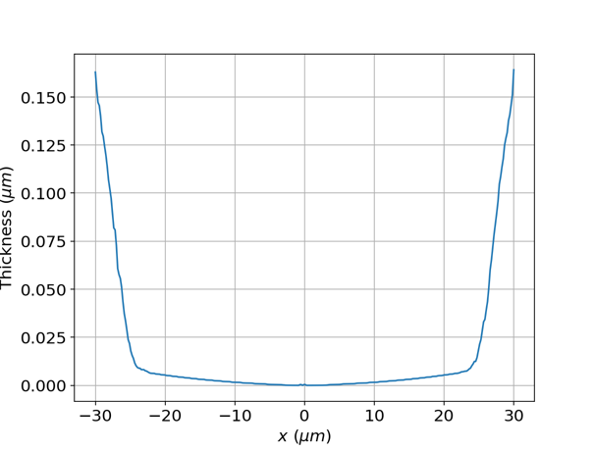 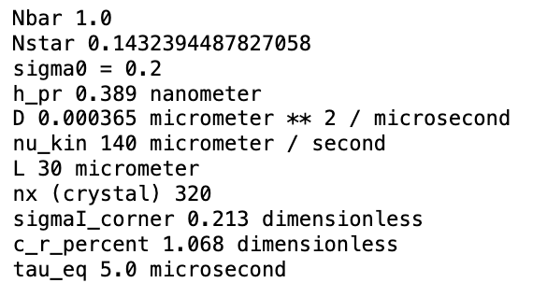

Here’s the *microfacet* result, same parameters as above (w/additional microfacet parameters displayed), run out to the times indicated. Curves have been shifted to have a minimum at zero thickness.

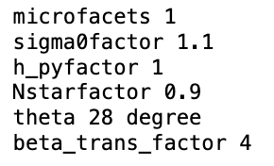

|  |  |
| --- | --- |
| 2000 ms |  |

|  |  |
| --- | --- |
| 8000 ms |  |

|  |  |
| --- | --- |
| 9000 ms |  |

Positive aspects of this trajectory include the fact that the horizontal spacing between adjacent peaks is the right order of magnitude, at $\sim 5-20 μm$, and the shapes are recognizably similar over the (long) time span of a second. Also, the surface has settled into angles corresponding to mostly pyramidal ( $±20°-30°$), as shown below (for 8000 ms):

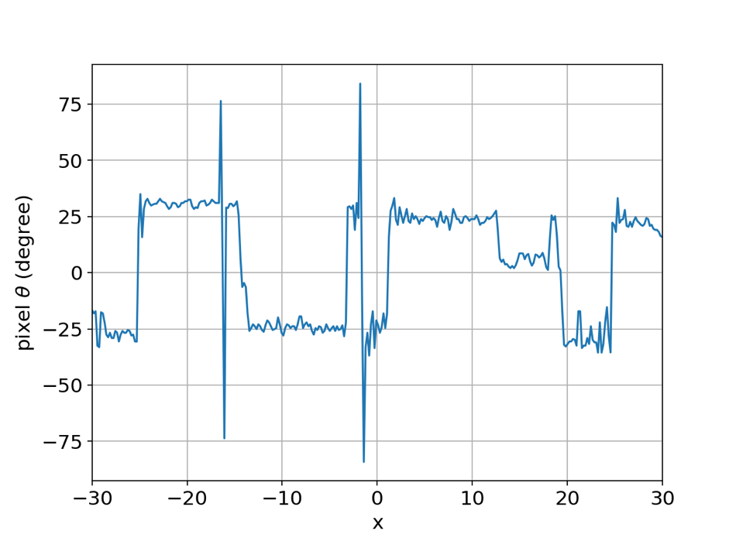

On the negative side, the vertical excursions are larger than observed in SEM. Also, we see that a new kind of instability has set in, in two locations at 8000 ms, and four locations at 9000 ms.